# Detailed Tech Architecture:

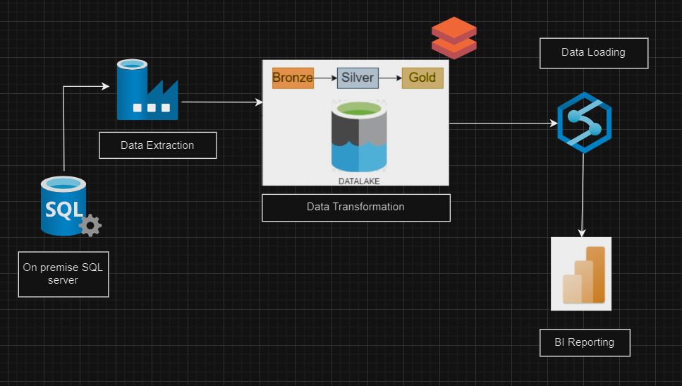

# Environment Setup

Resource Group & Resources Created:  
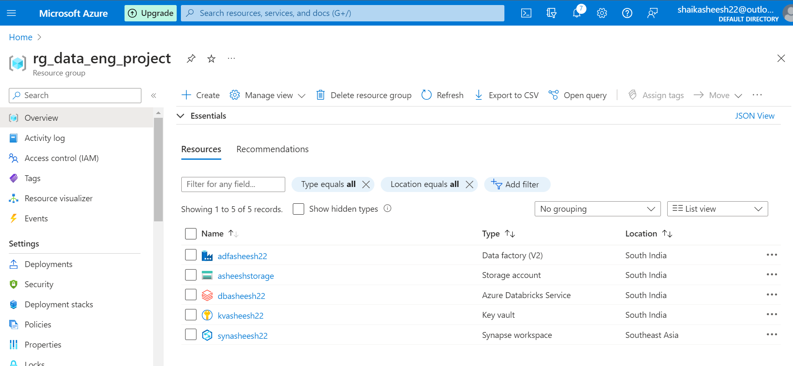

Data based is stored on prem sql server

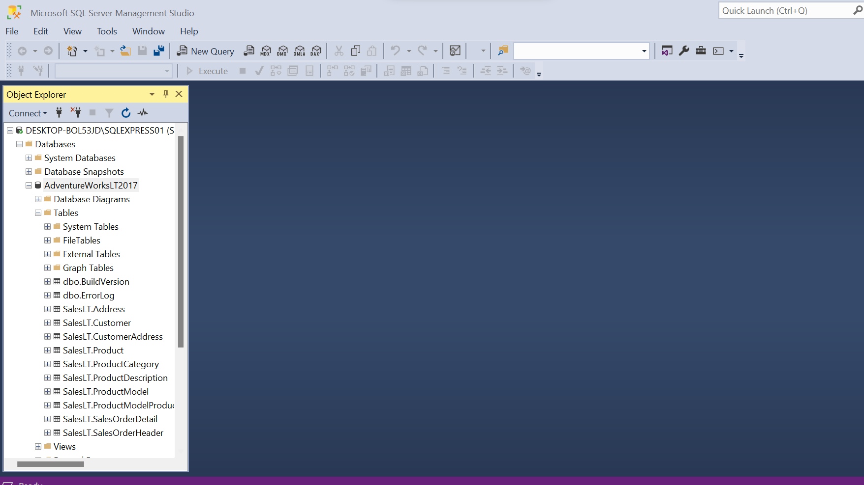

Create Login and user for the current database to enable SQL authentication  
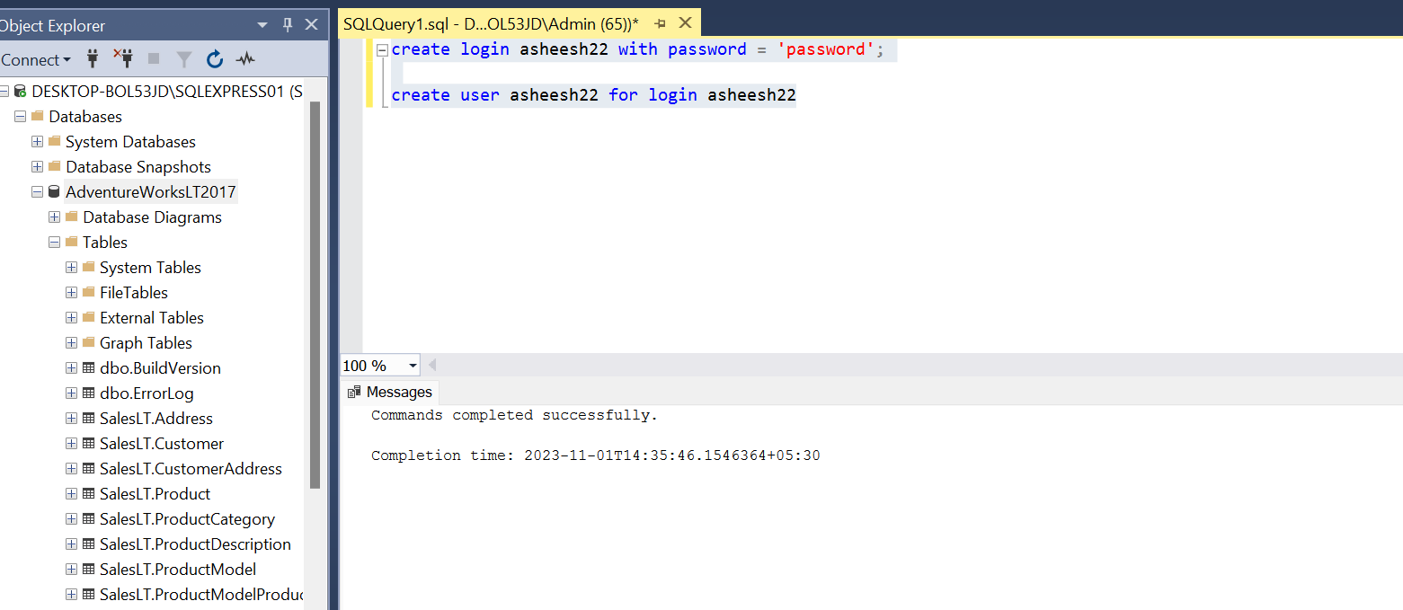

Once login and user are created, assign role to the created user  
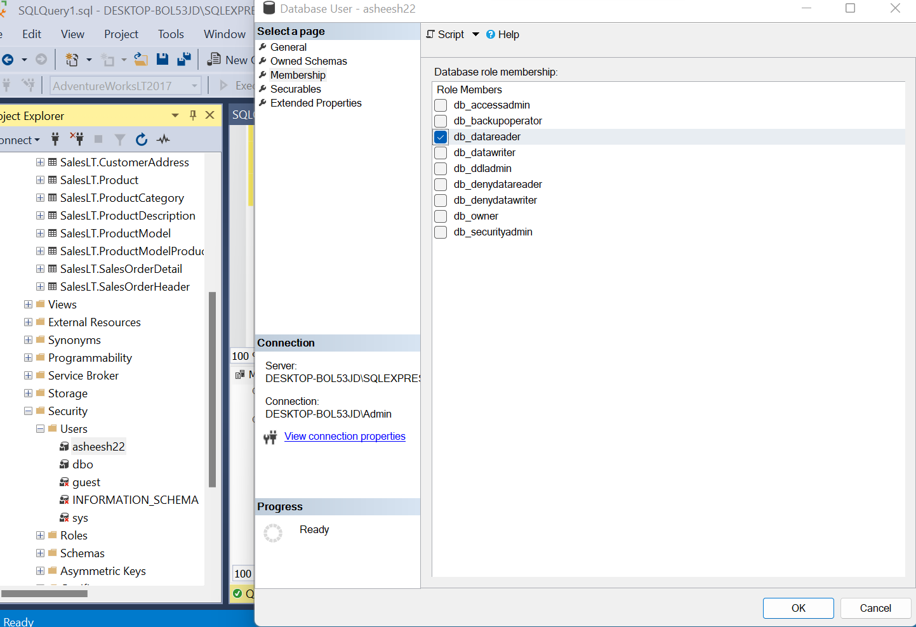

Creating Key vault for storing secrets

Resolved this error first before creating secrets <https://stackoverflow.com/questions/69971341/unable-to-create-secrets-in-azure-key-vault-if-using-azure-role-based-access-con>

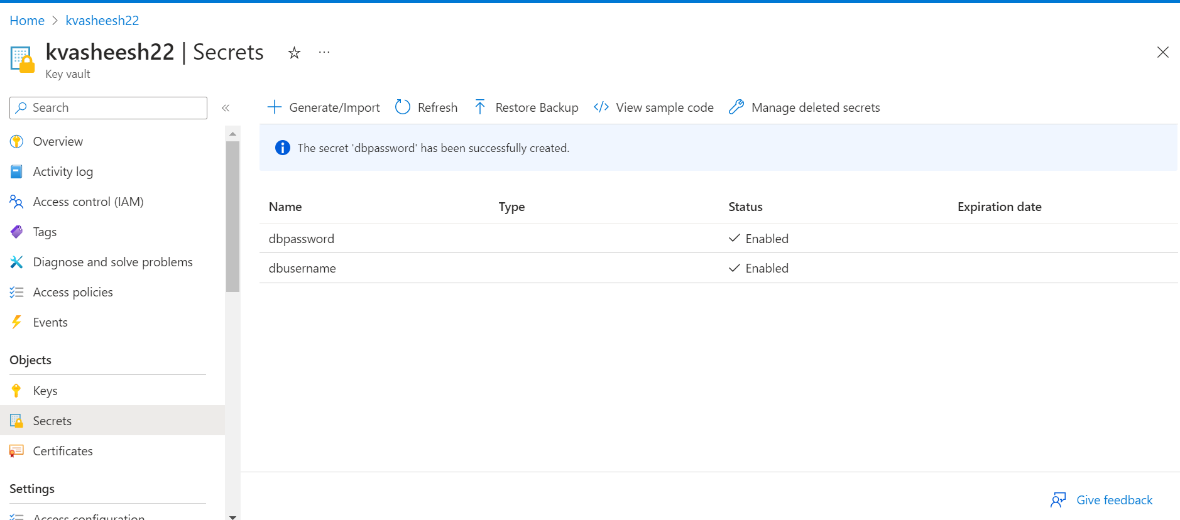

# Data Ingestion:

Install self hosted integration run time in premise to establish connection between sql server and adf

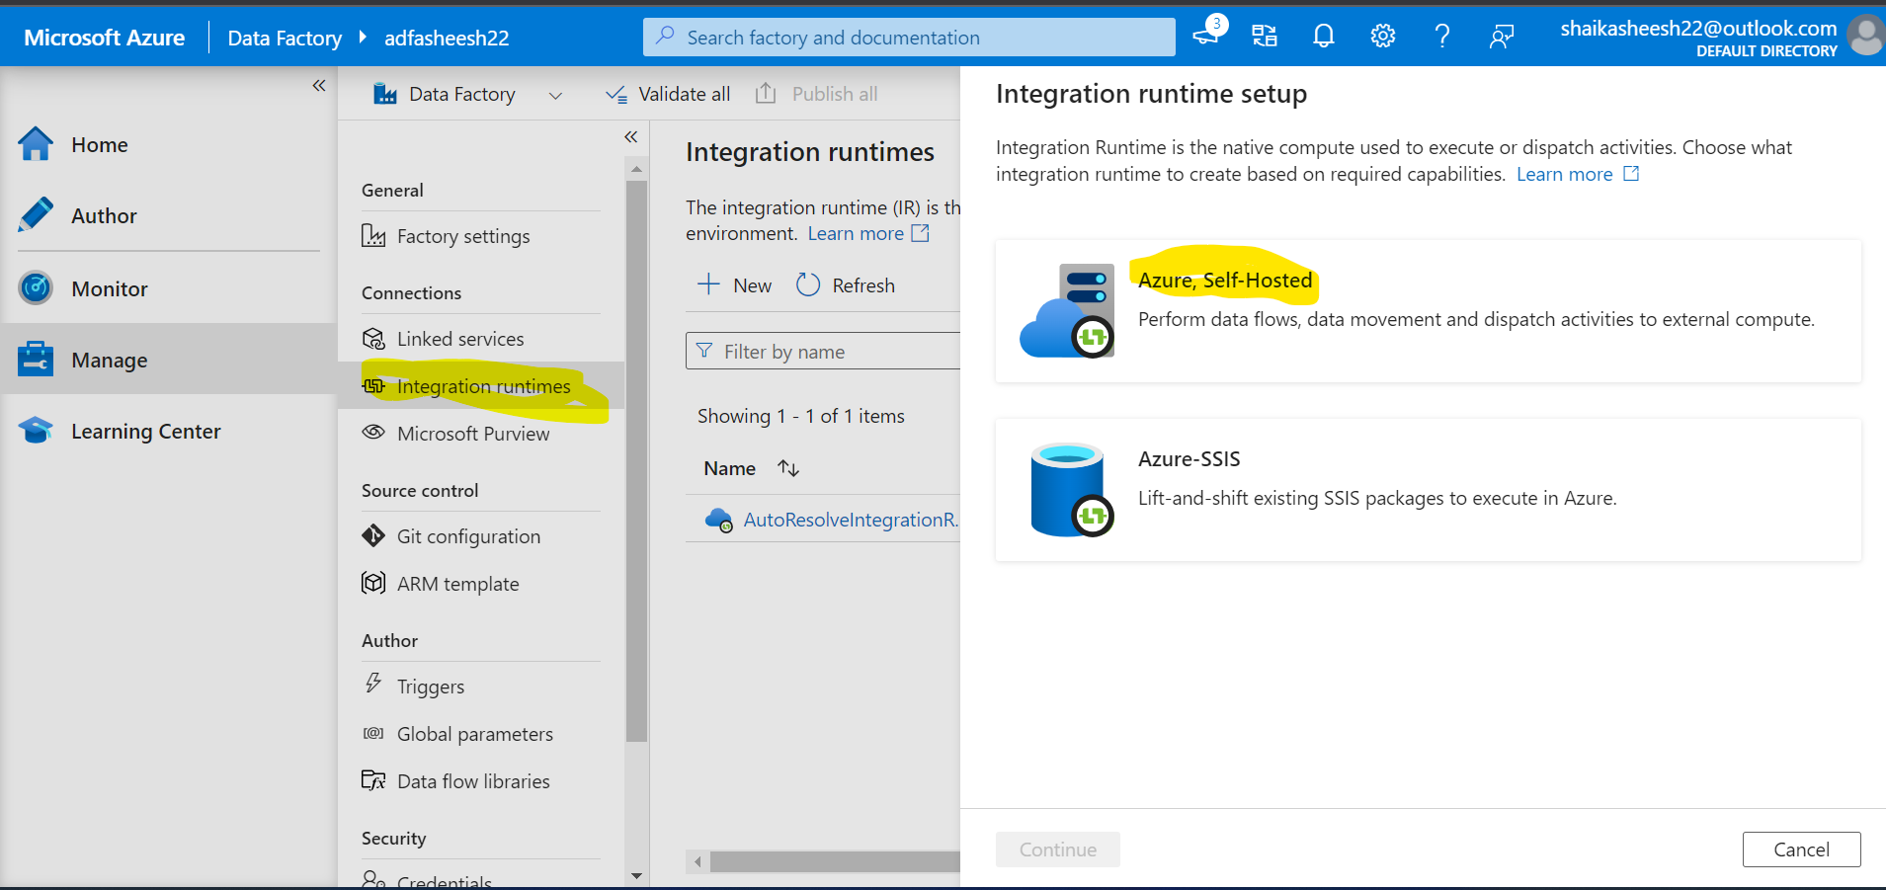

SelfHostedIntegration run time is created

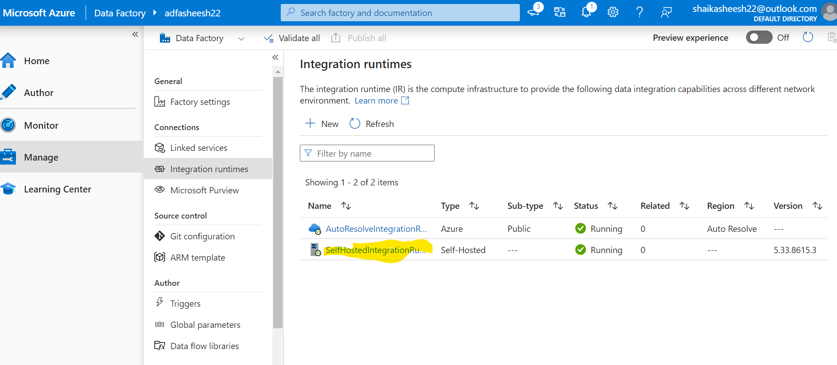

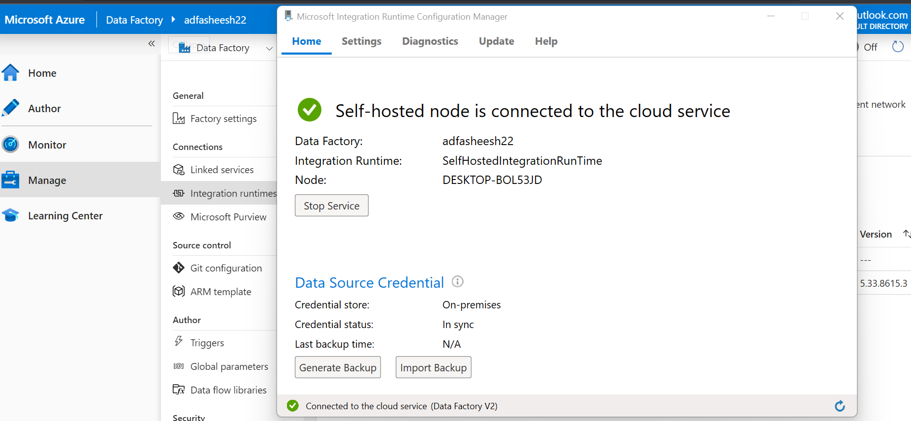

Creating Pipelines in ADF for data ingestion using Copy data Activity

Source:

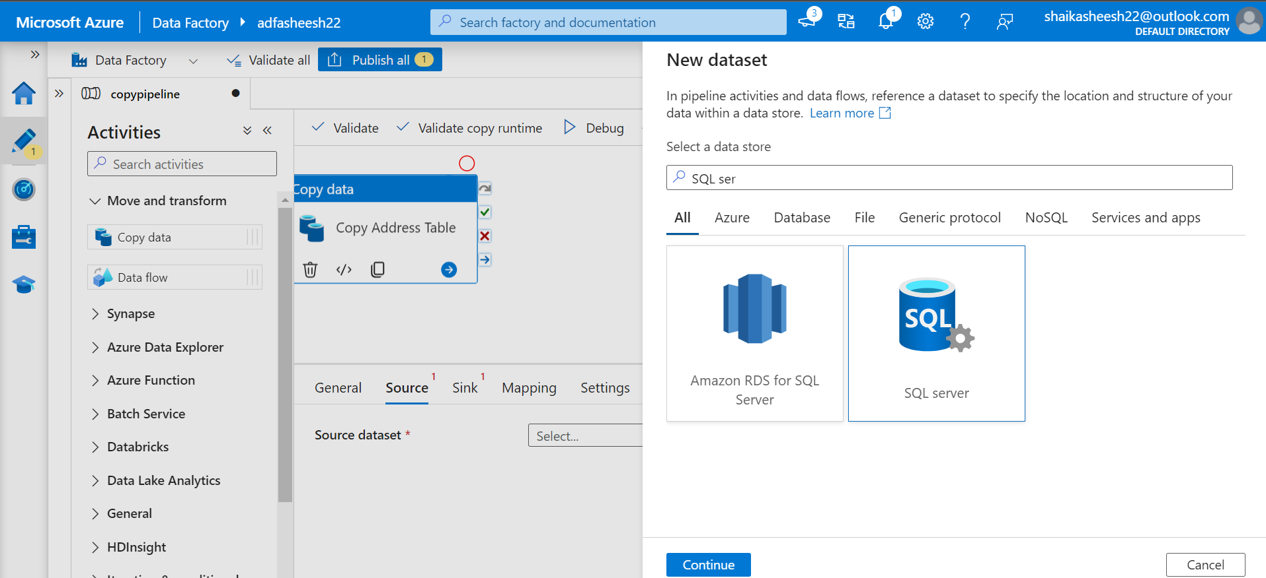

Creating Linked Service

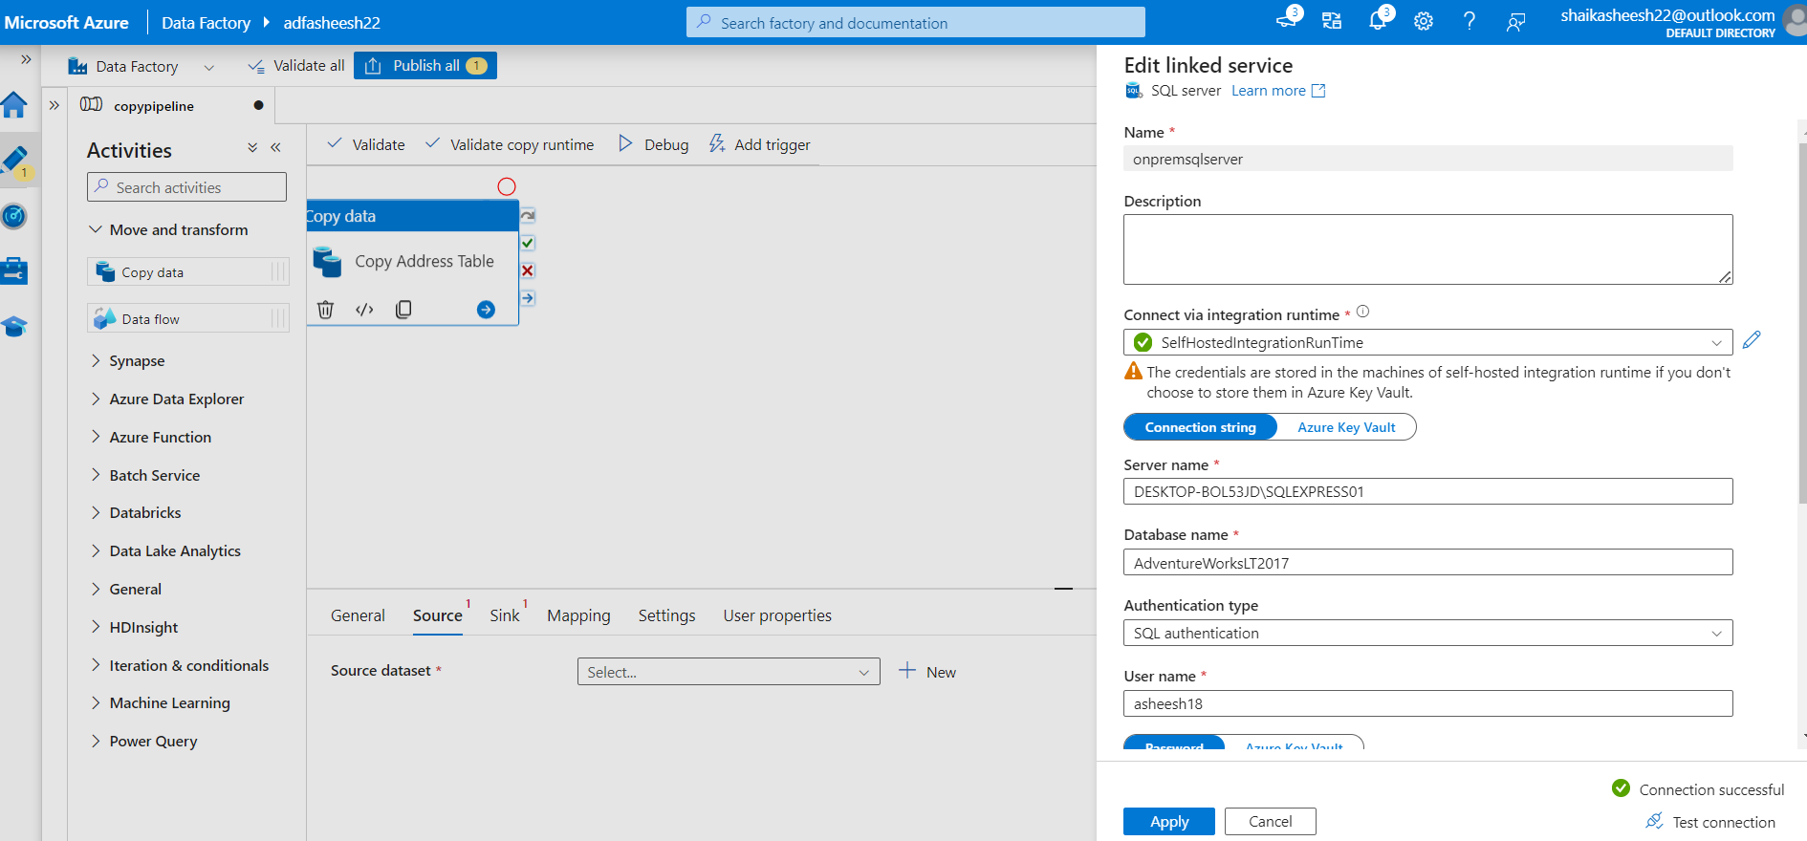

Once linked service is created click on OK to add source data set

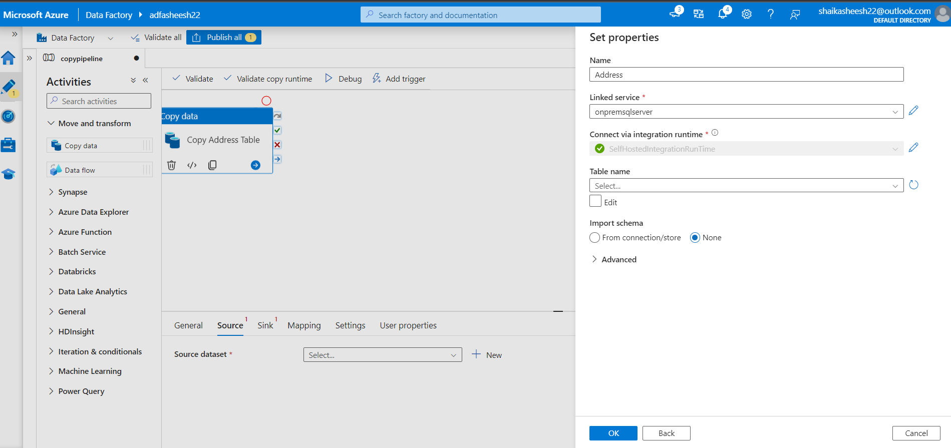

Creating Sink Data set using ADLS gen 2

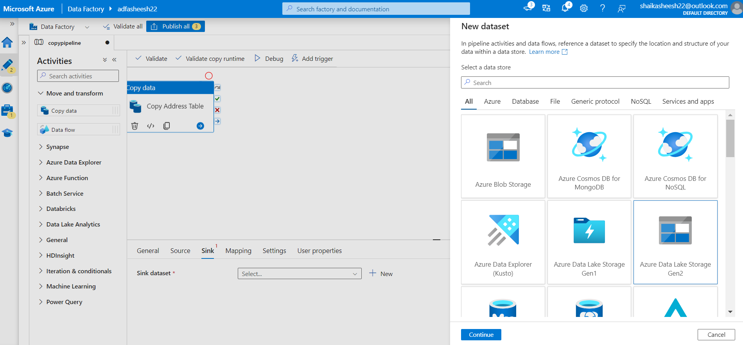

Selecting format of the file

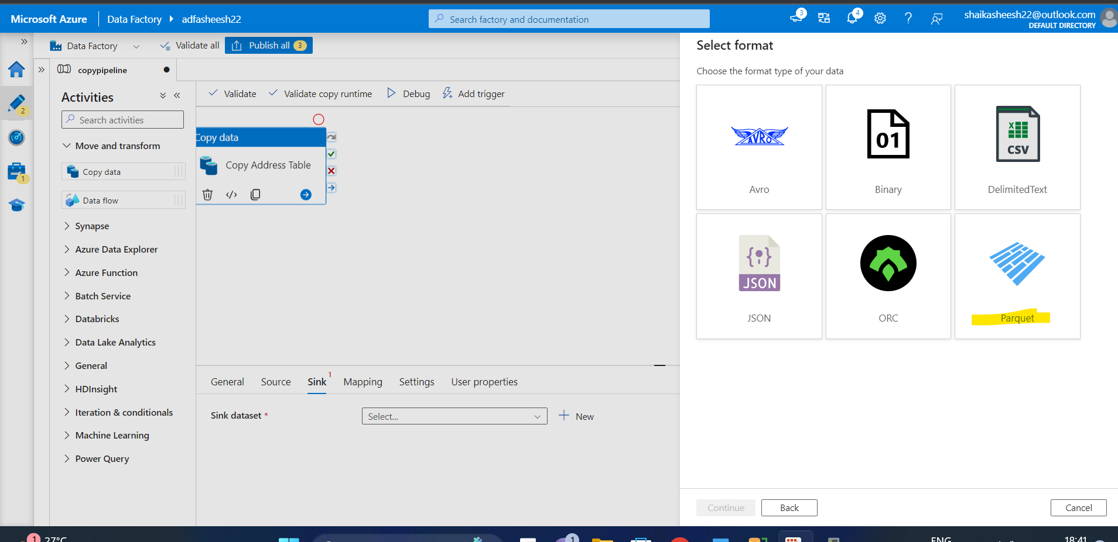

Creating Linked service

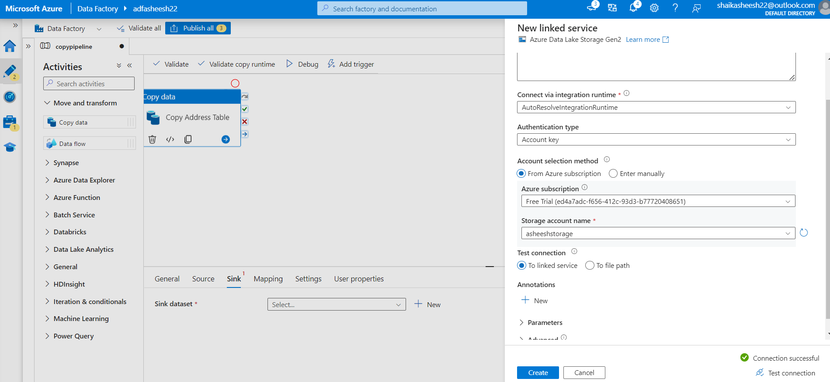

Note #changed container from asheeshfiles to bronze

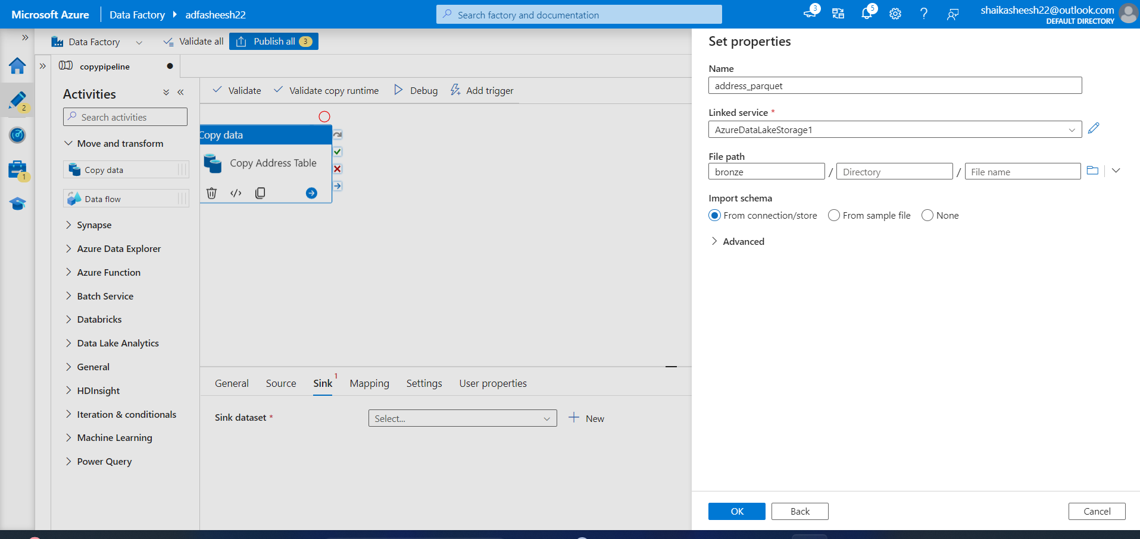

Now get all the tables in one go using look up activity and query option

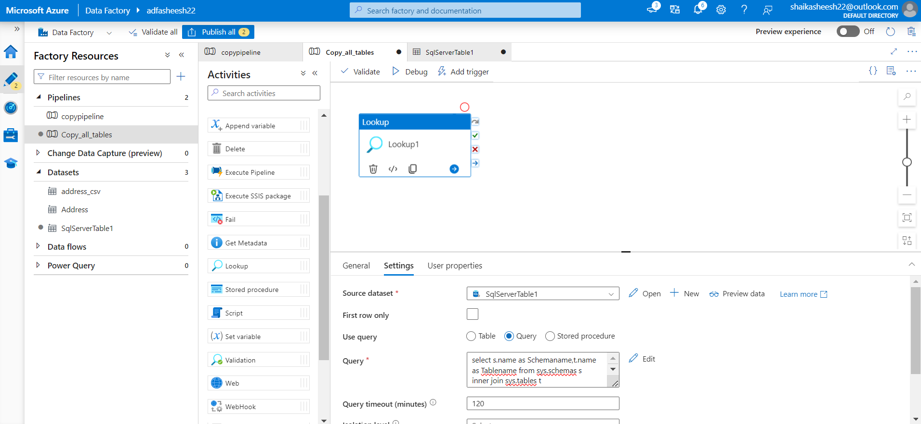

Query to get all the table names for the DB

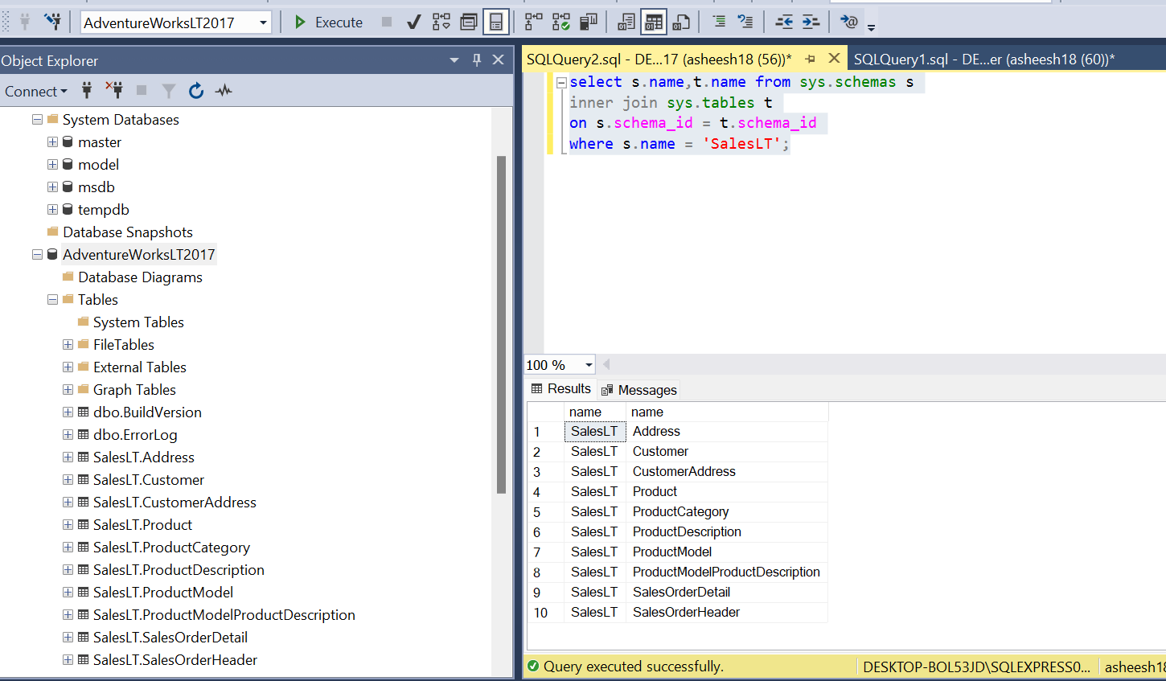

Adding for each activity and feeding lookup1 output as input

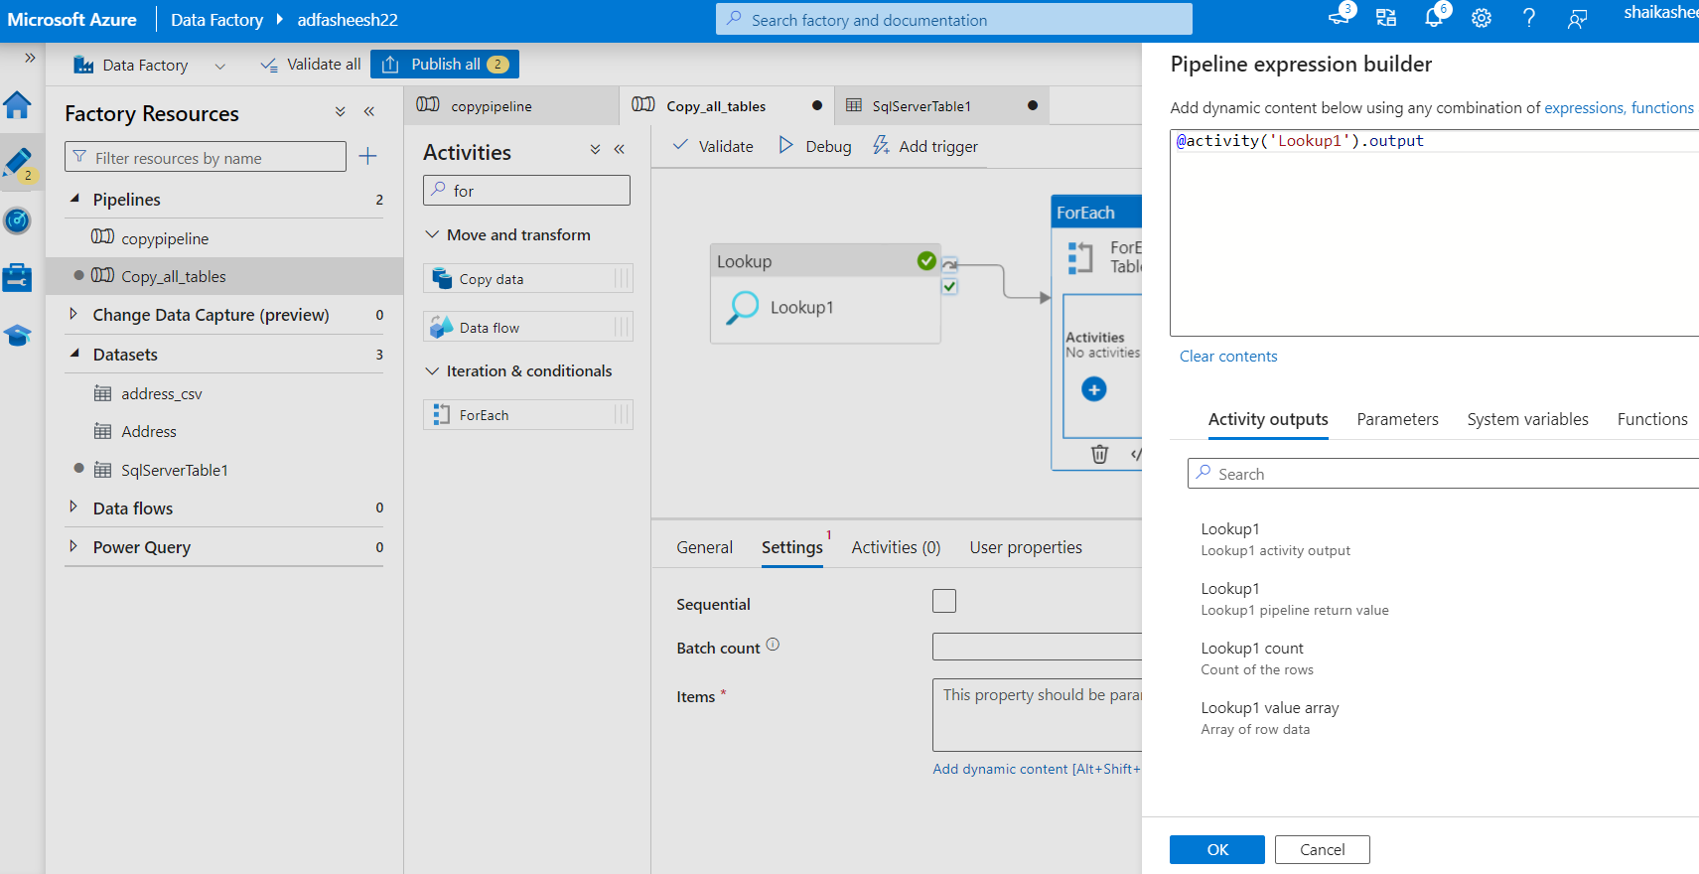

Inside for each, copy activity is added to copy each table

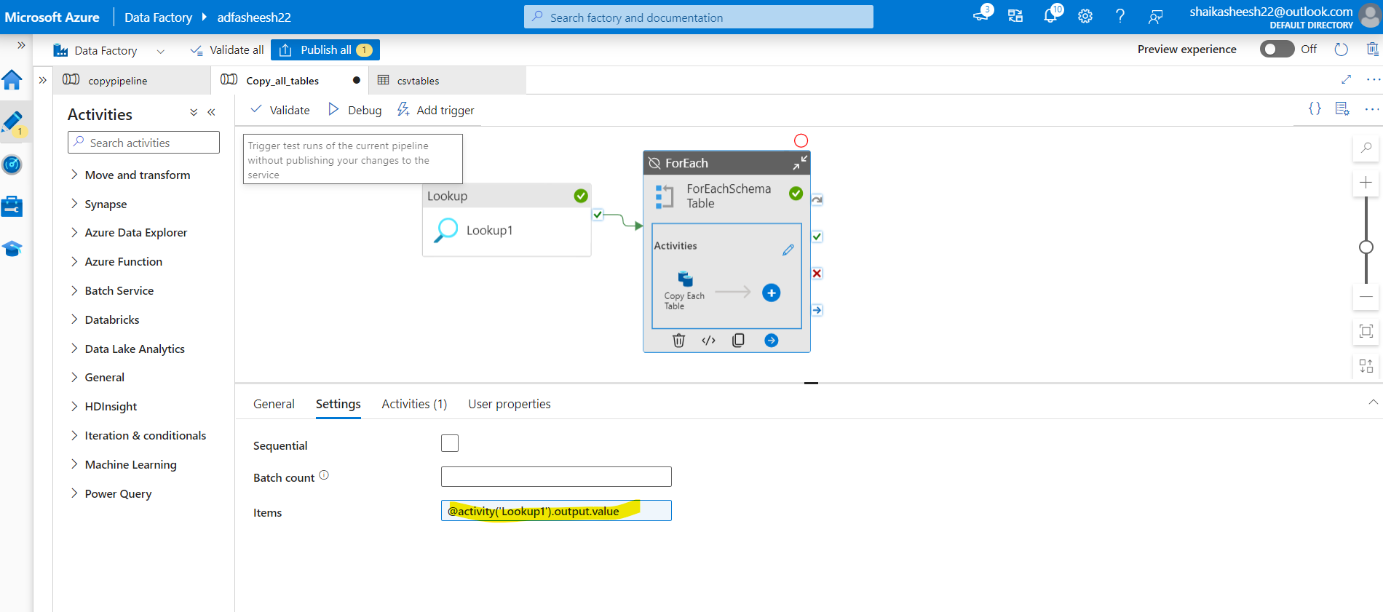

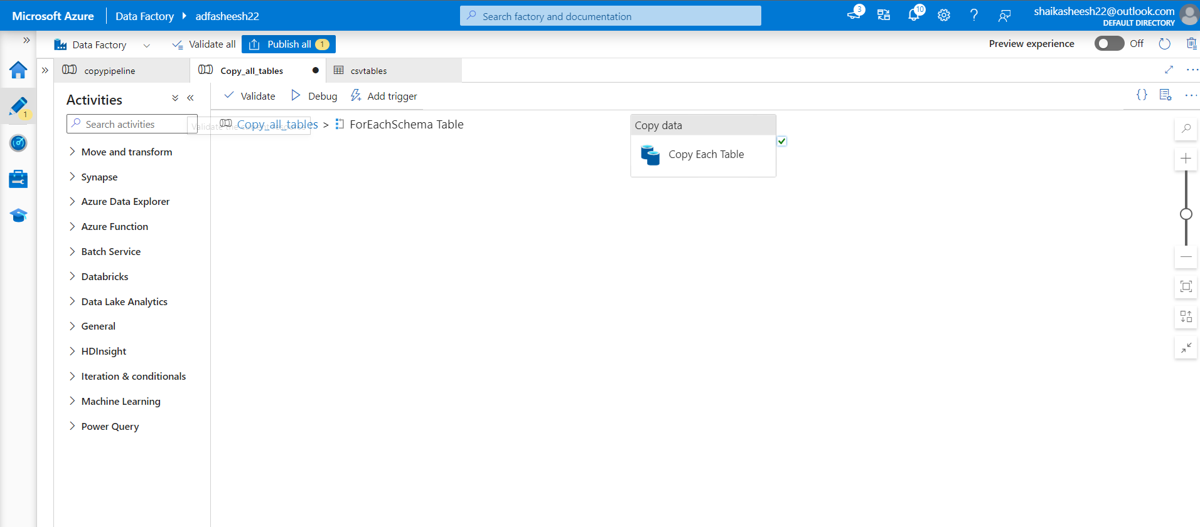

Setting up source for copy each table using query option

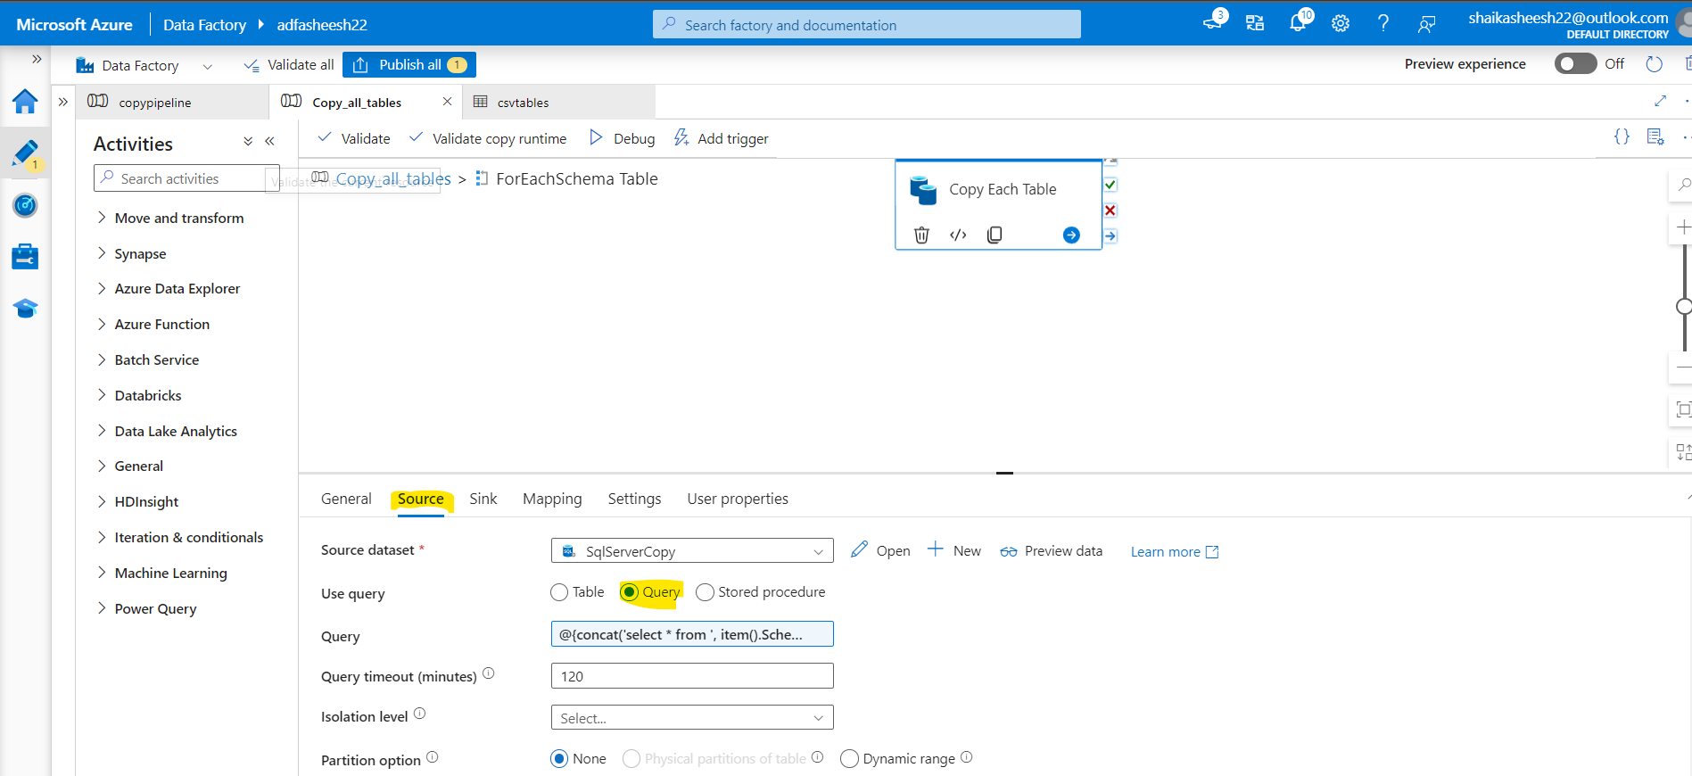

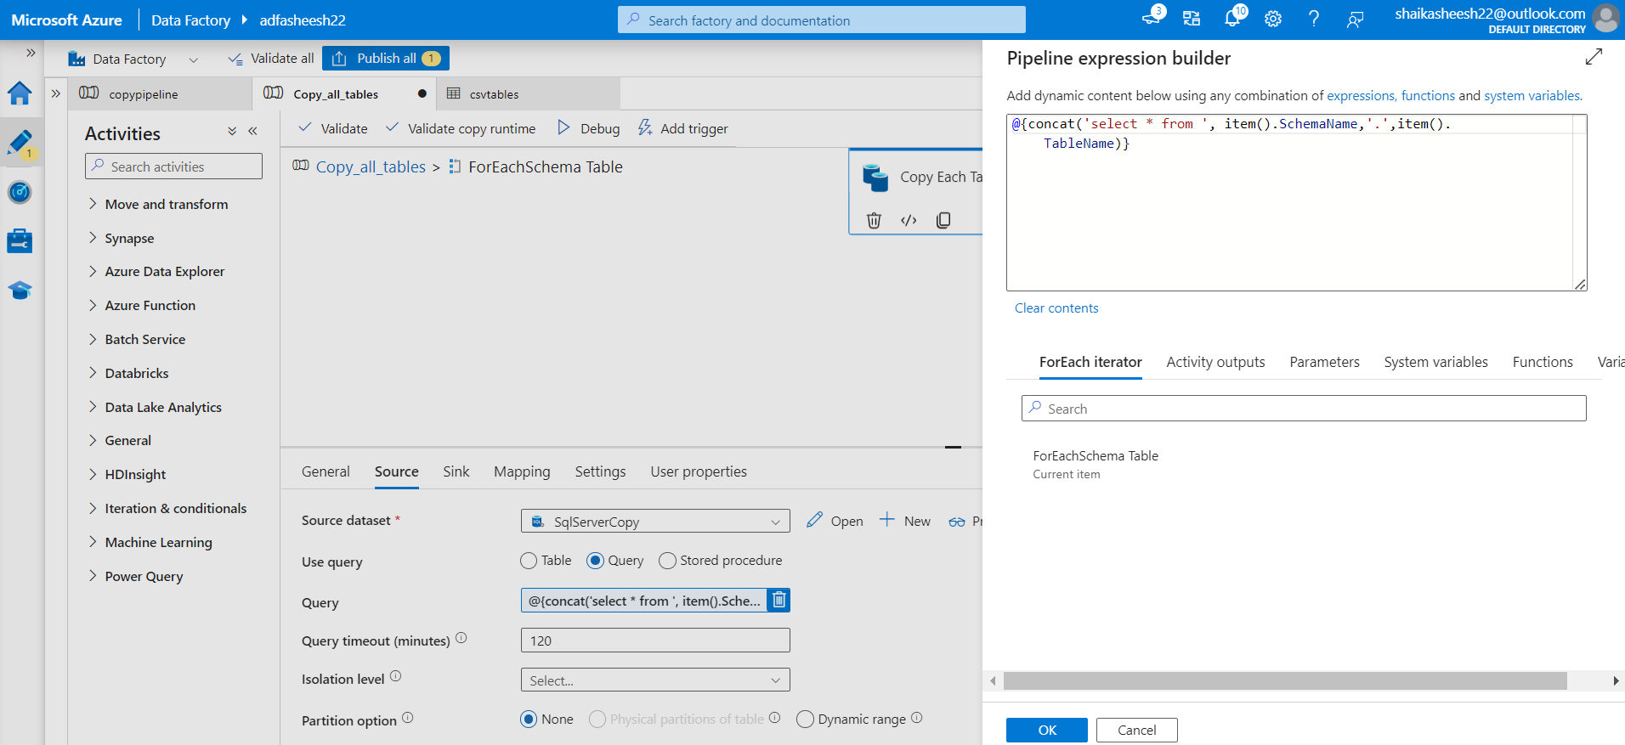

Setting up the sink data and adding schema name and table name as parameters

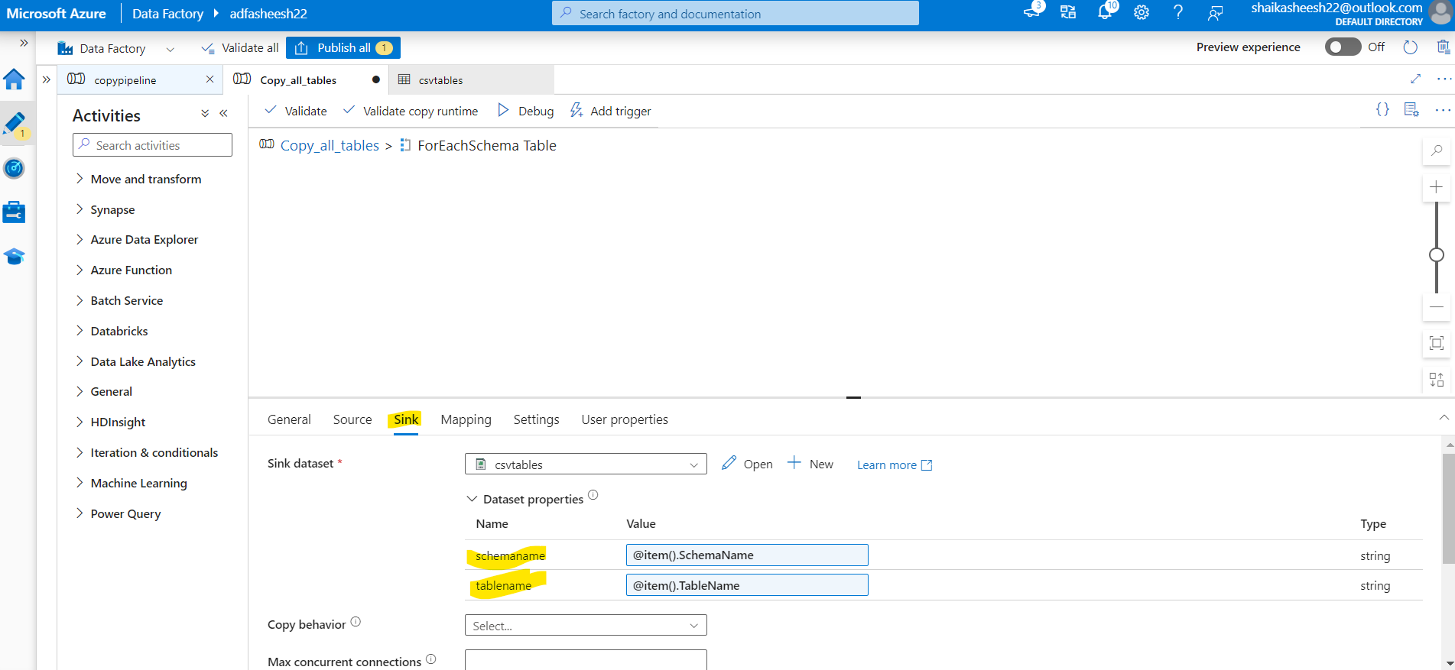

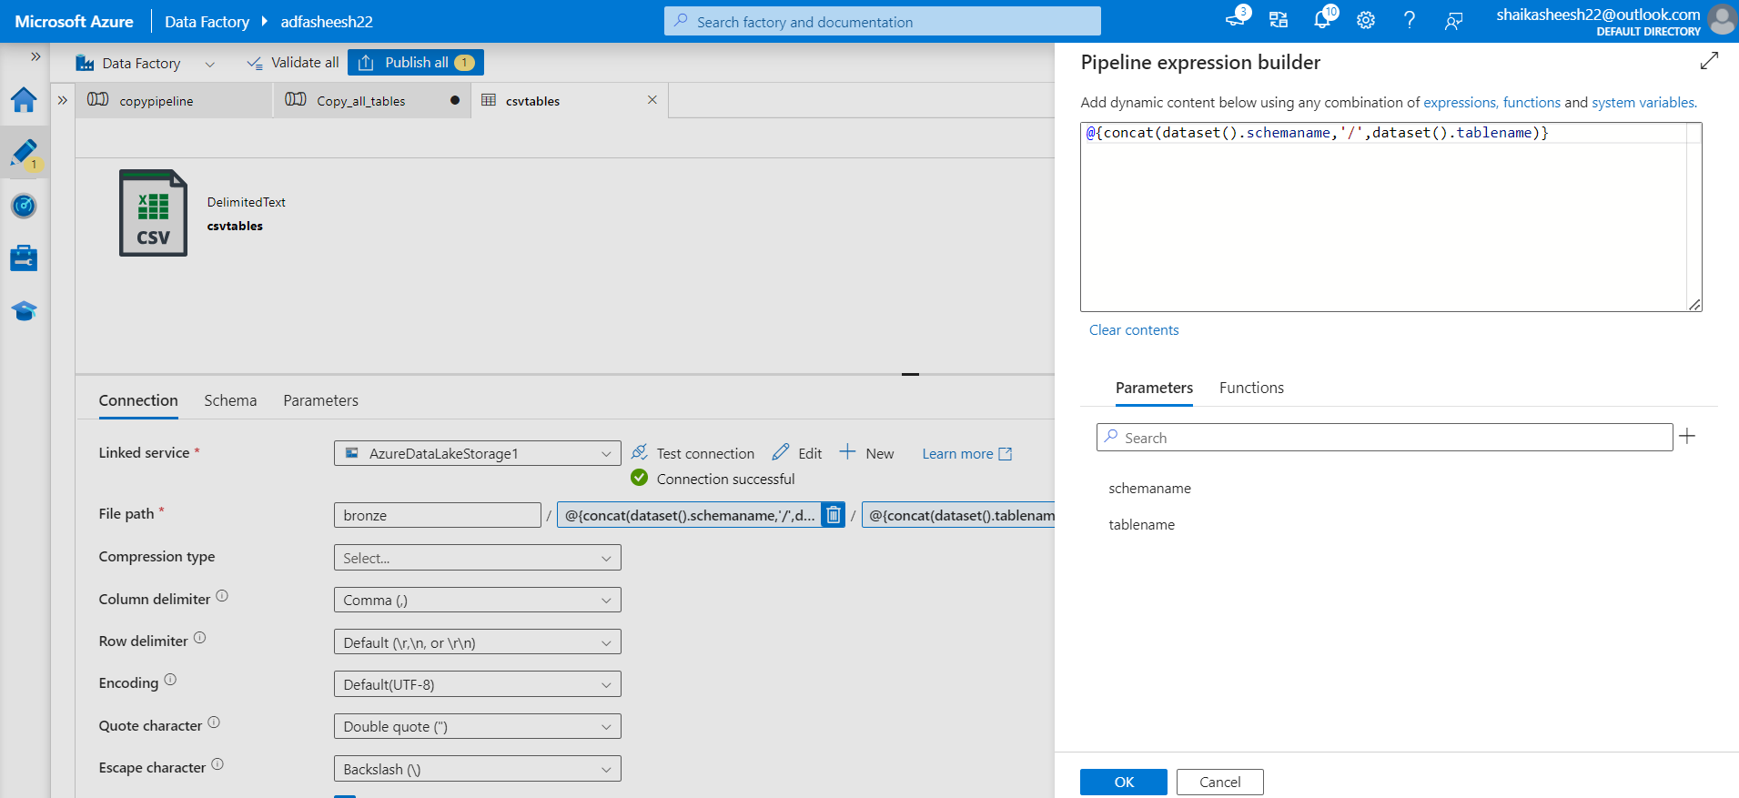

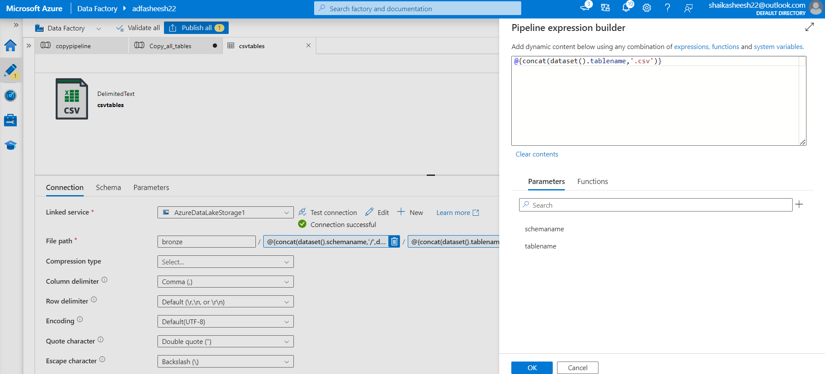

Pipeline built successfully

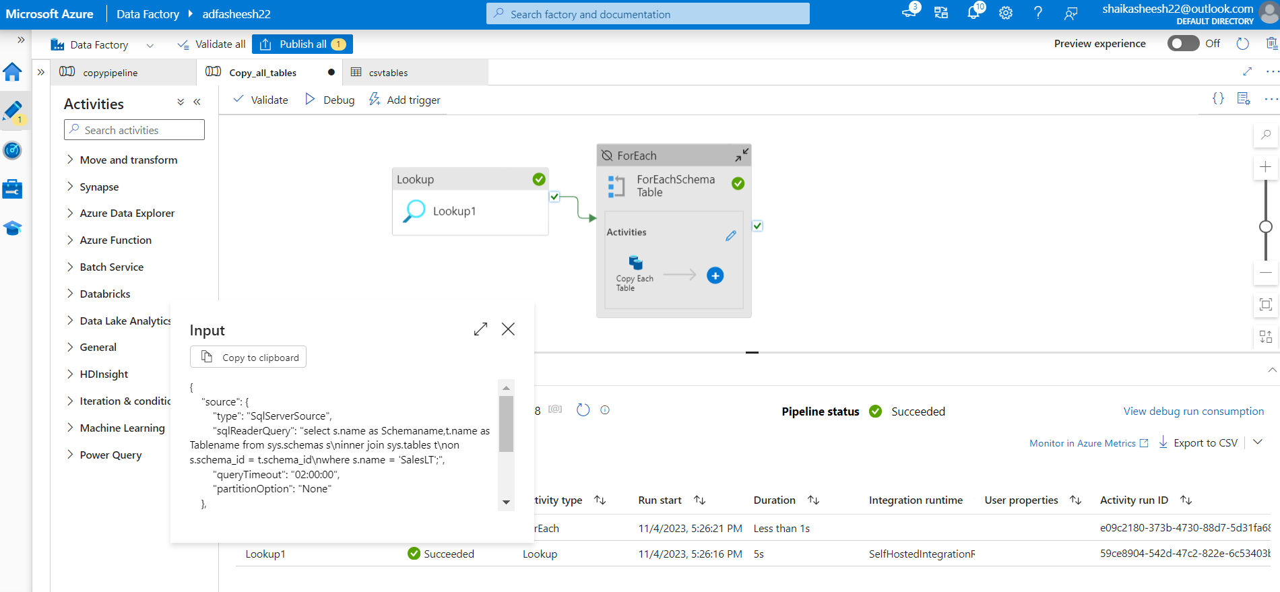

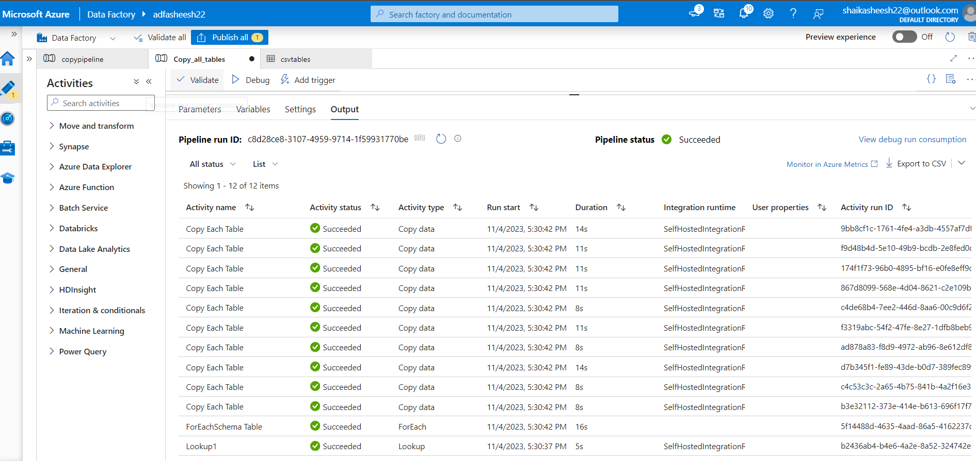

Files are present in bronze layer

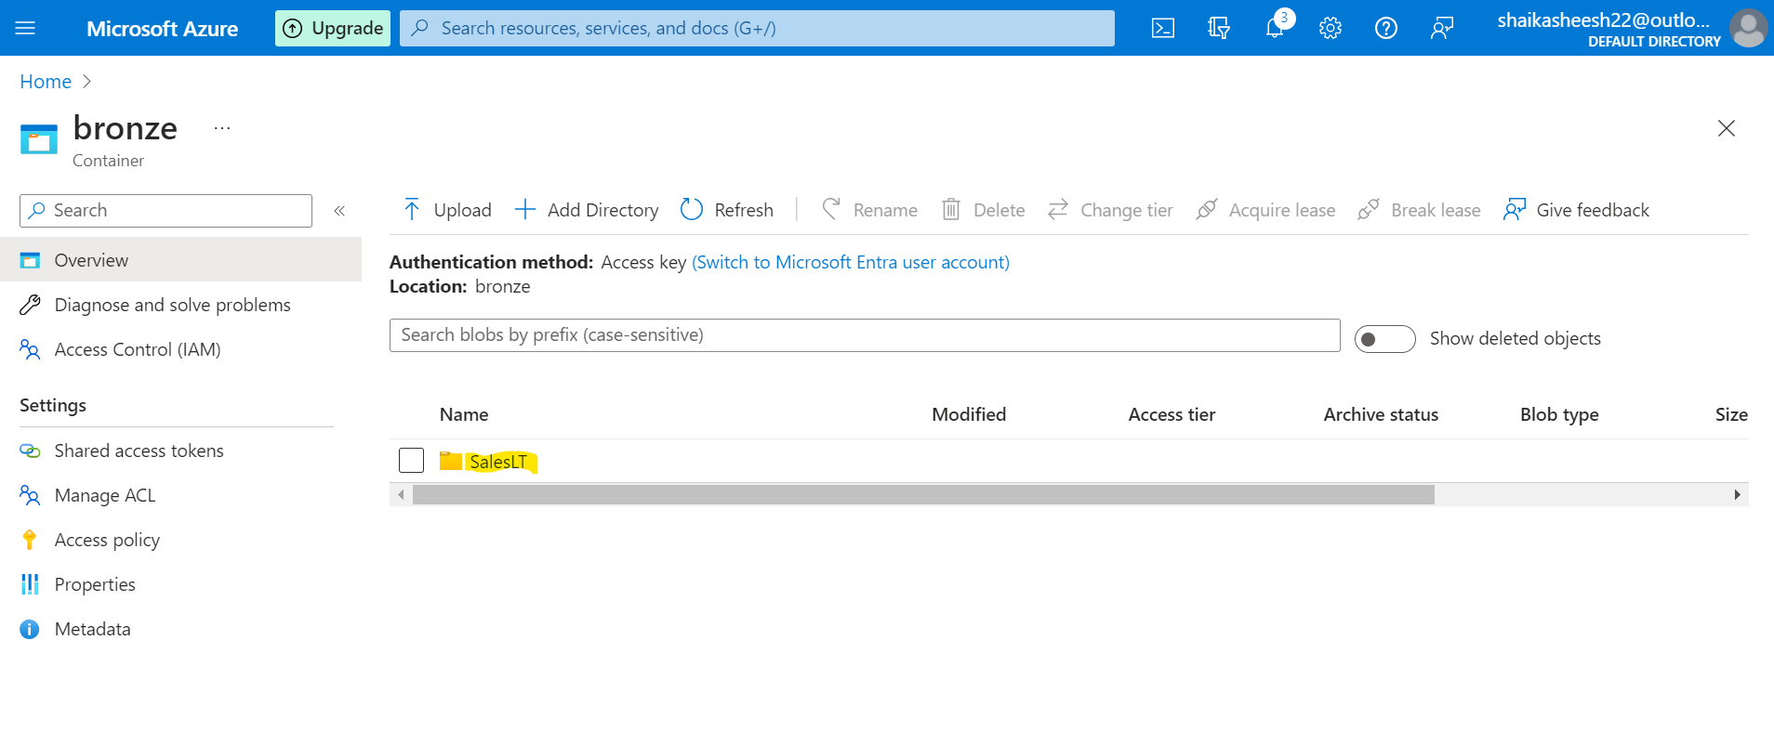

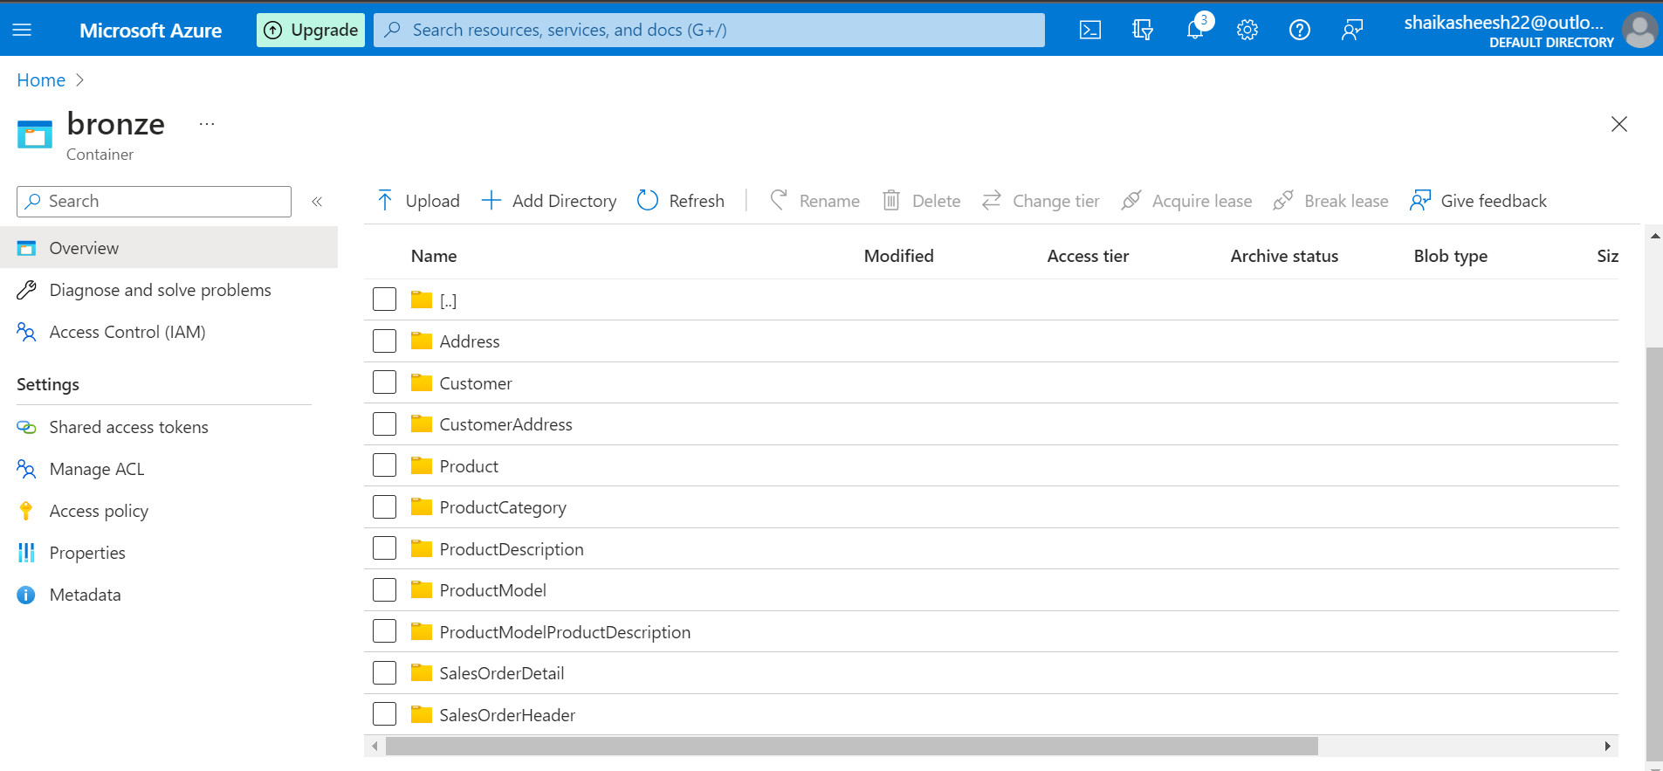

Data Ingestion Completed !!!

# Data Transformation DB:

Creating a compute in databricks workspace

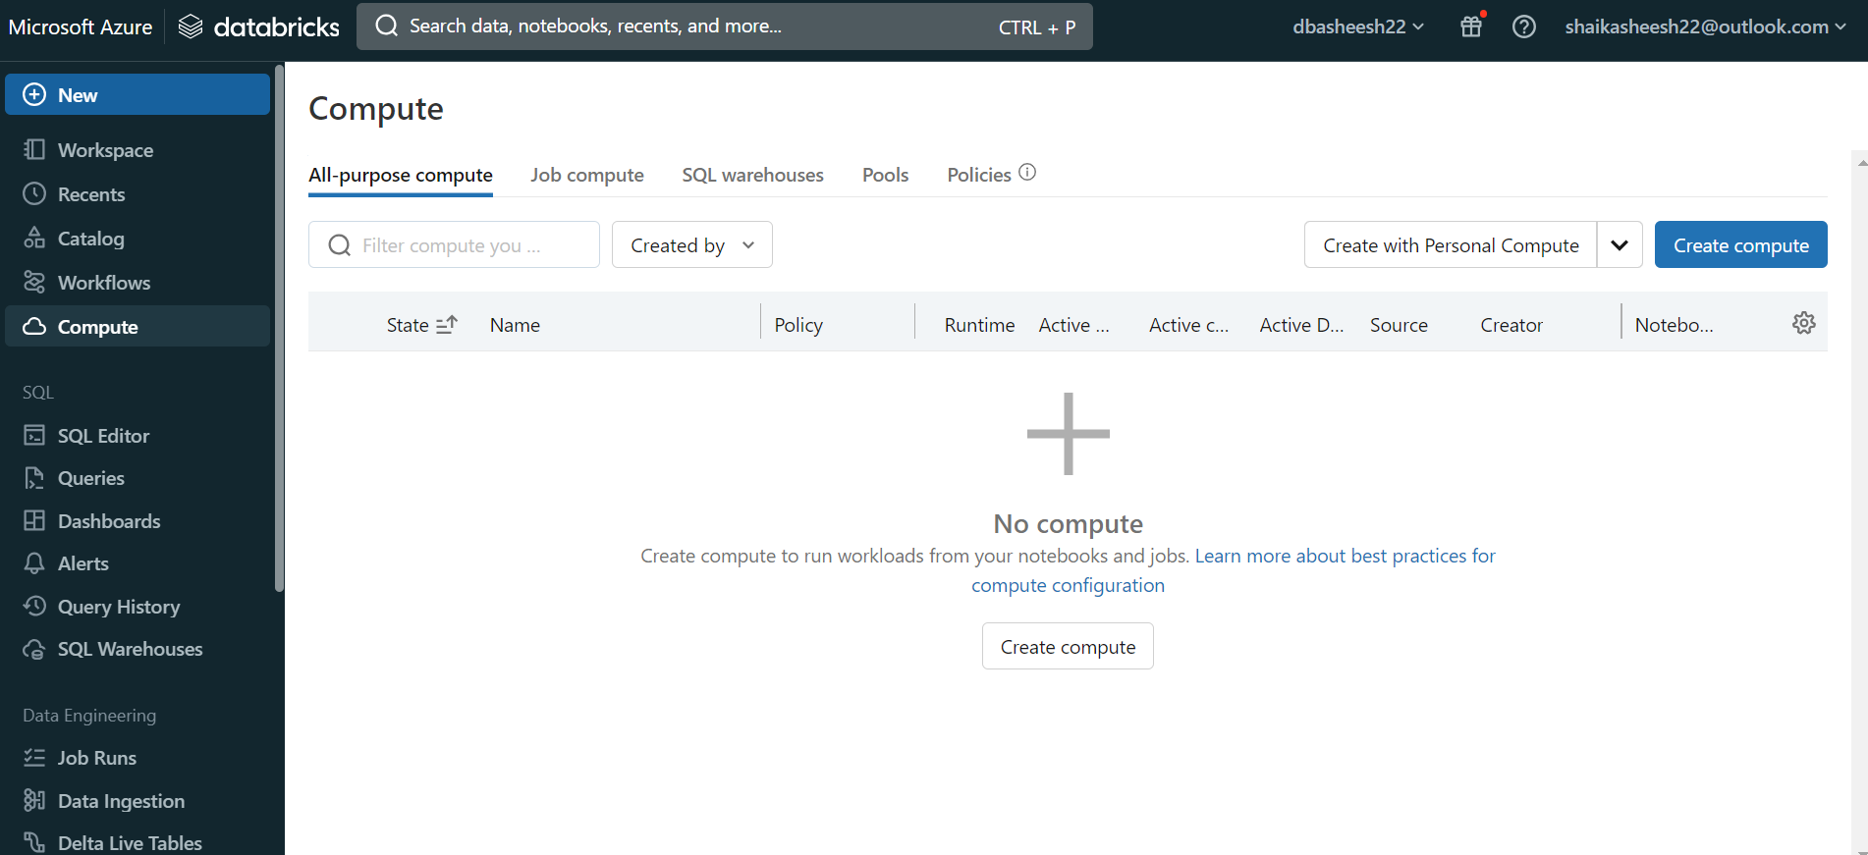

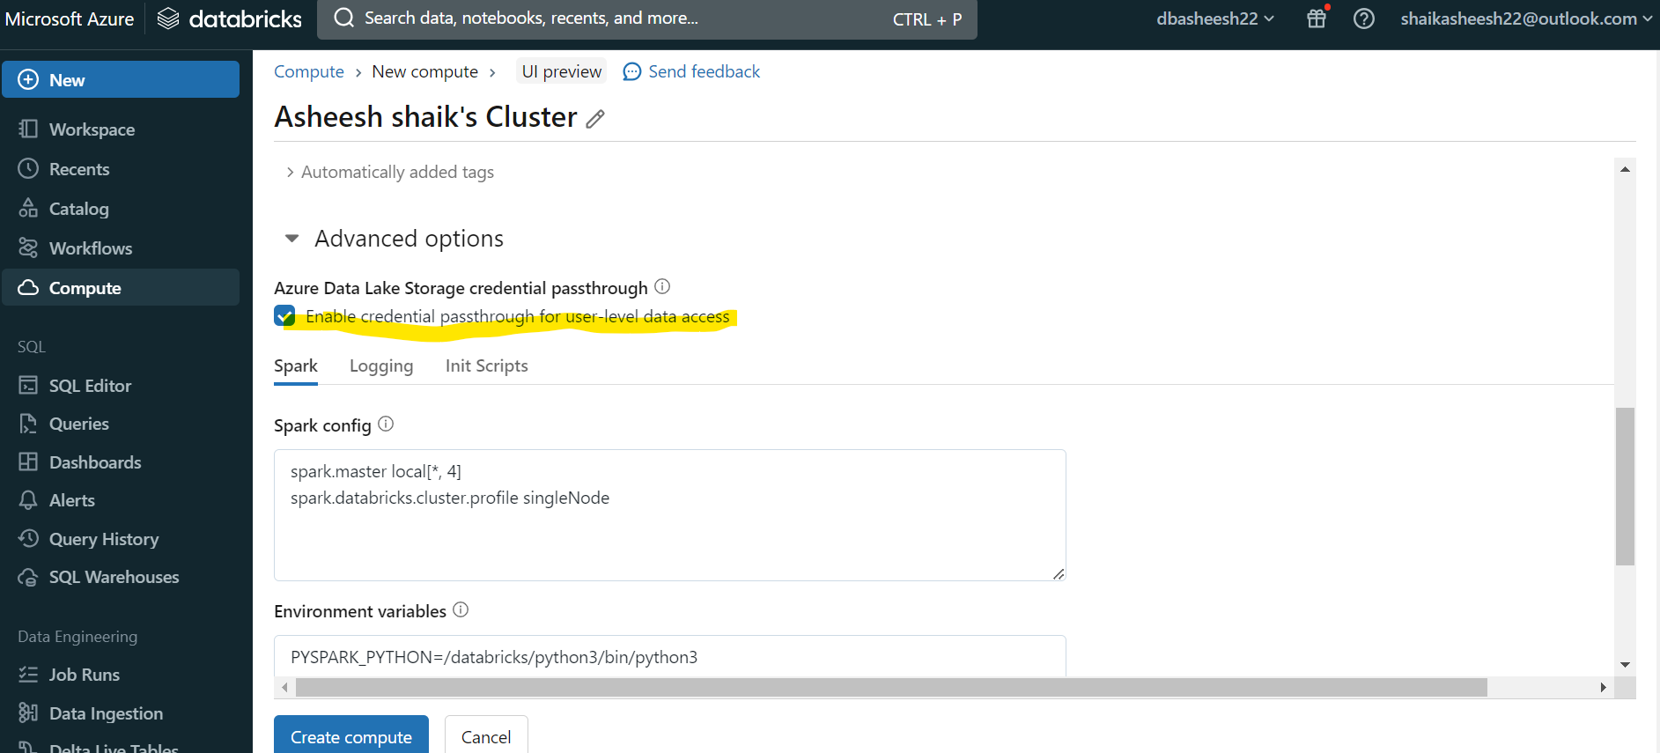

Get code for config using below link for credential pass through

<https://learn.microsoft.com/en-us/azure/databricks/data-governance/credential-passthrough/adls-passthrough>

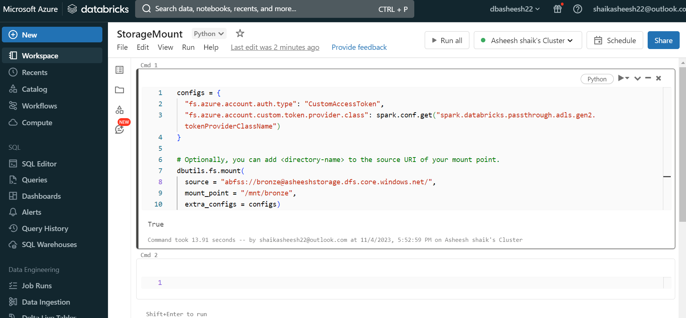

Mounting Data is completed !!!

Notebook Link for Transformation Steps:



Transformation steps are completed. We need to add it to ADF pipeline

Databricks Linked Service creation

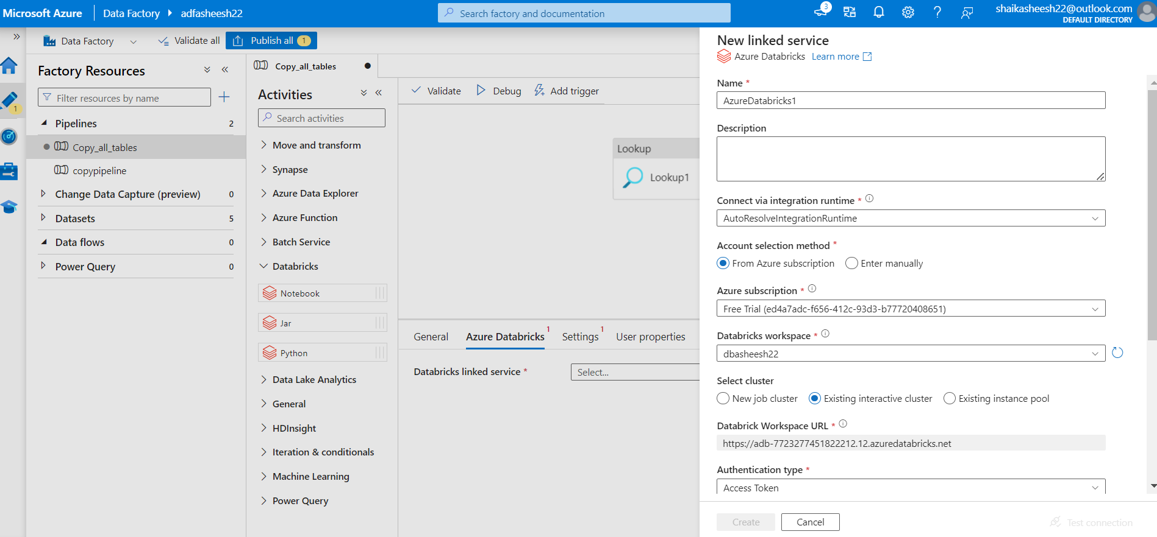

Create access token from Databricks user profile settings and add it here

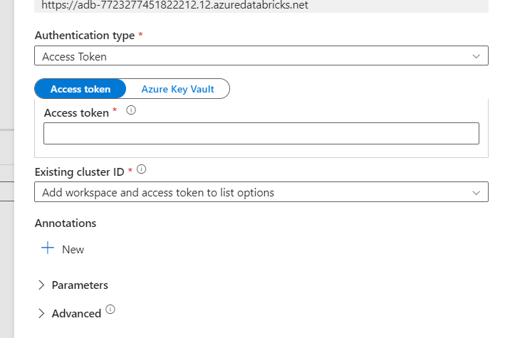

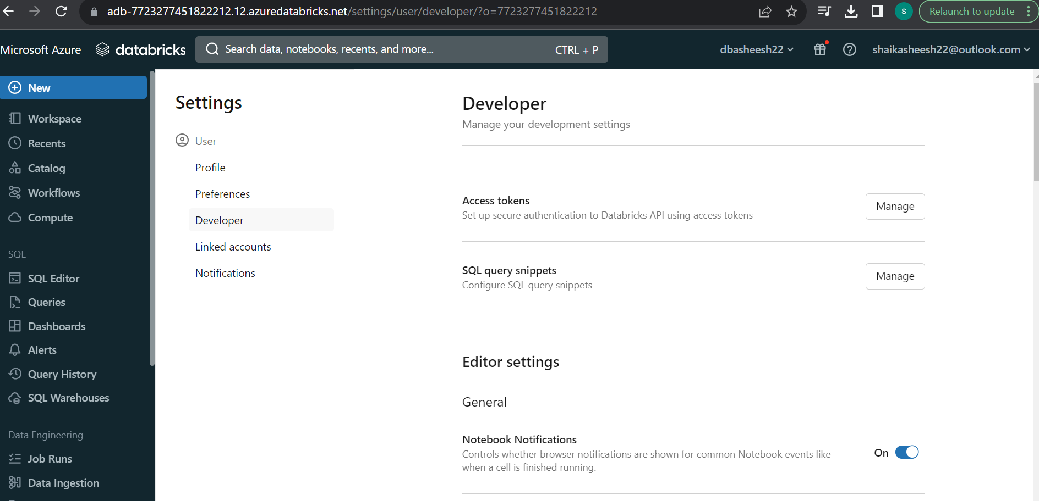

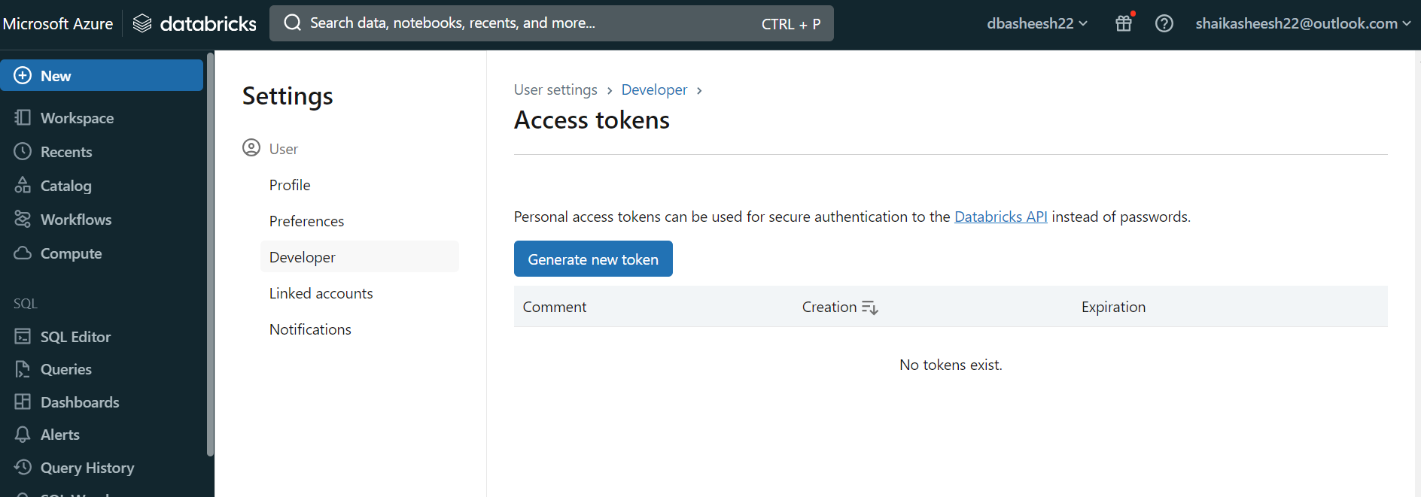

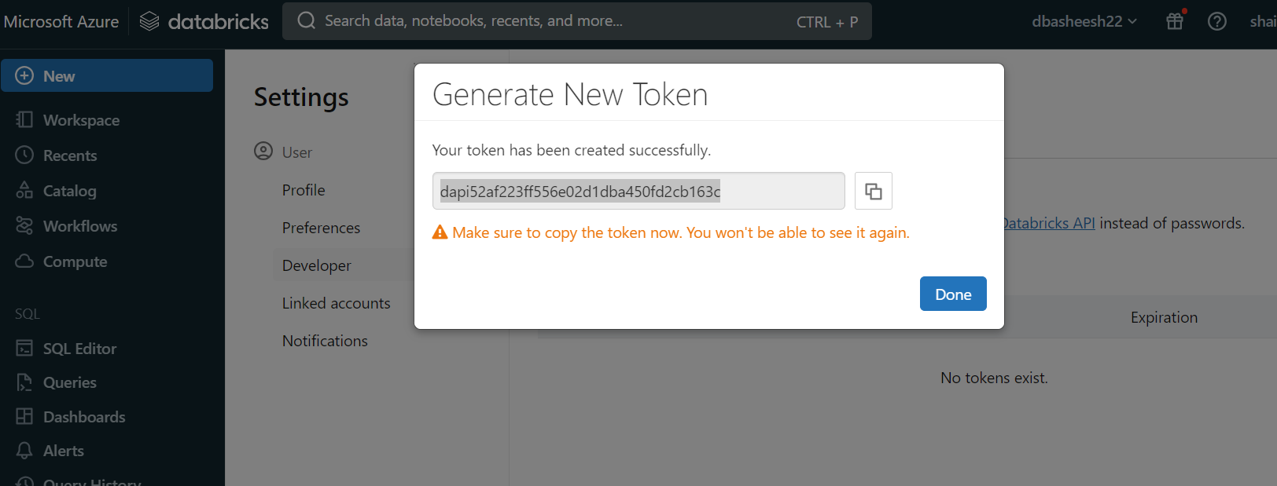

Test the connection:

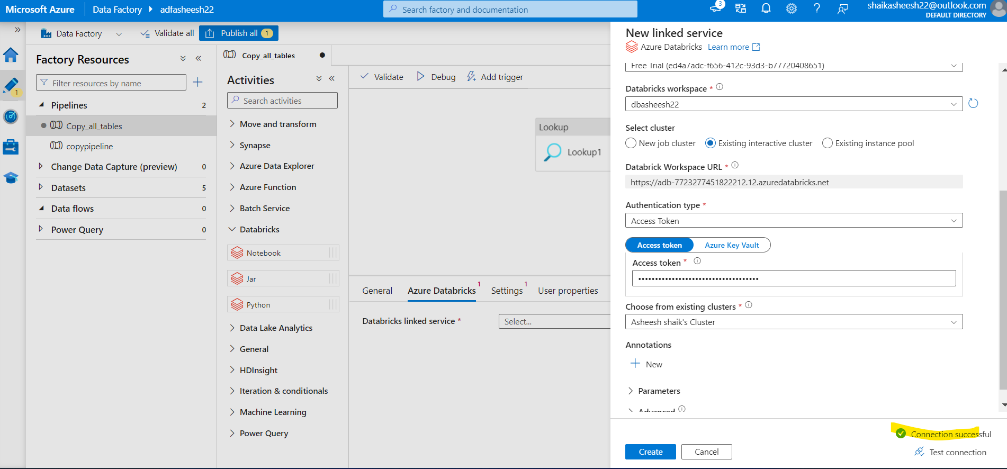

Pipeline is succeded from Data Ingestion to Data Transformation:

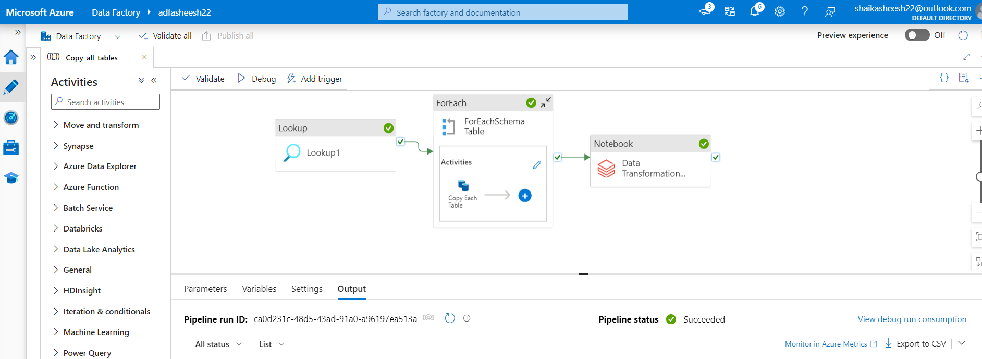

# Data loading into Synapse Studio

Create database

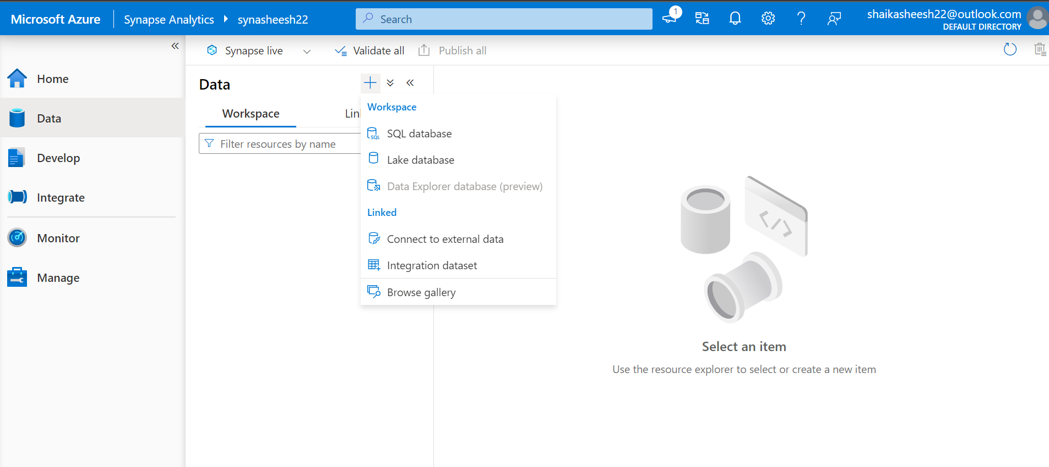

Data base is created Gold_Db

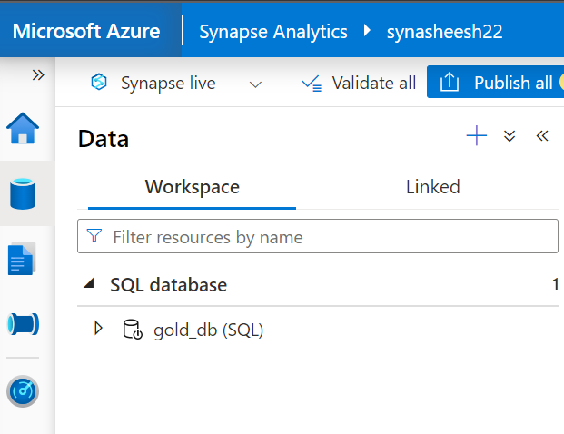

#Create views for all the tables as pipeline in synapse analytics

#Create a stored procedure script to build the views dynamically and below is the script

use Gold_DB

GO

create or alter PROCEDURE CreateSQLServerlessView_gold

@ViewName NVARCHAR(100)

AS

BEGIN

DECLARE @statement NVARCHAR(MAX)

    SET @statement = N'create or alter view' + quotename(@ViewName) + ' AS

    SELECT

     *

    FROM

    OPENROWSET(

        BULK ''https://asheeshstorage.dfs.core.windows.net/gold/SalesLT/' + @ViewName + '/'' ,

        FORMAT = ''DELTA''

    ) AS [result]

'

EXEC (@statement)

END

GO

Creating the SQL data base linked service and for domain name copy the serverless end point from synapse analytics properties.

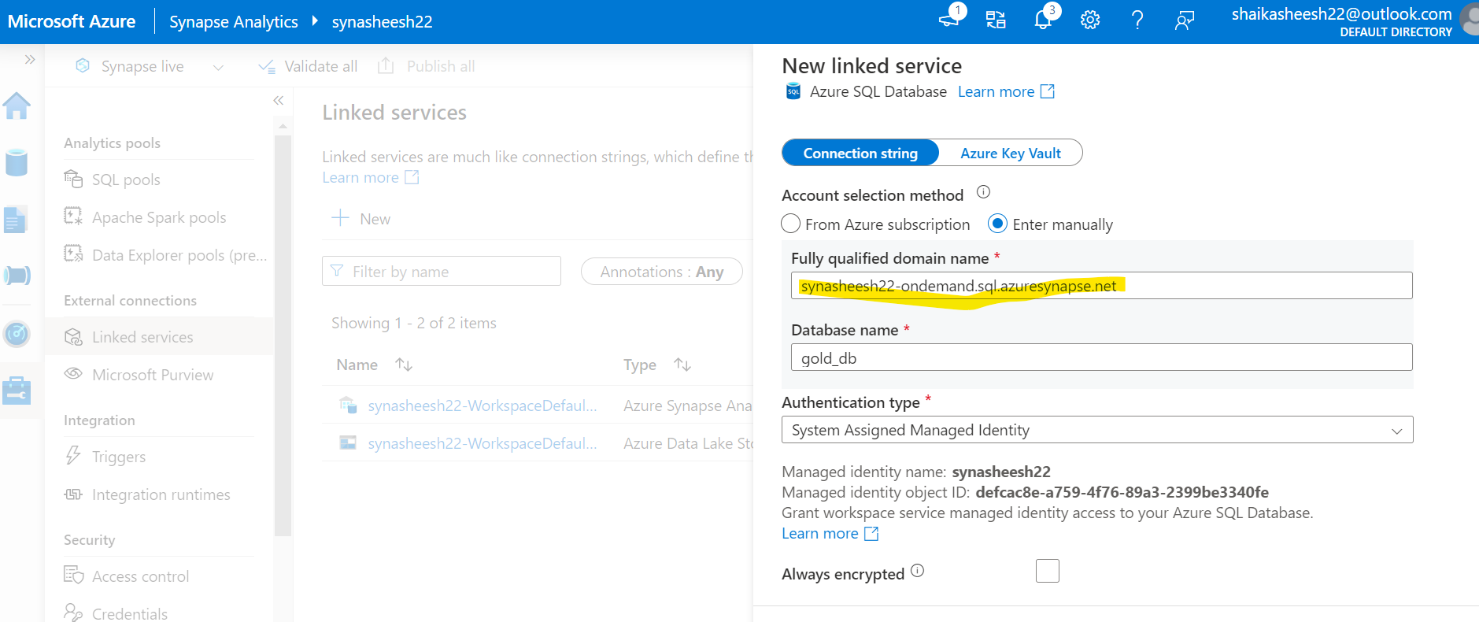

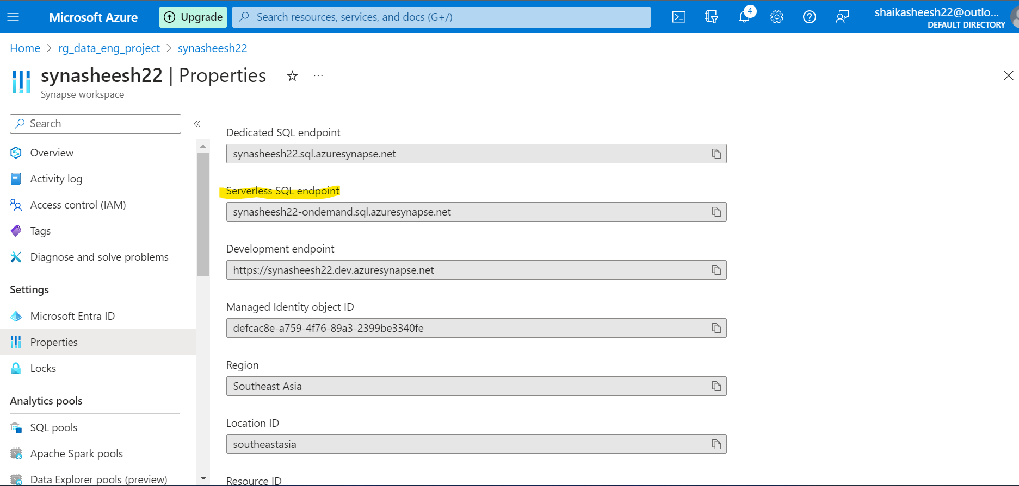

Connection is succesfull

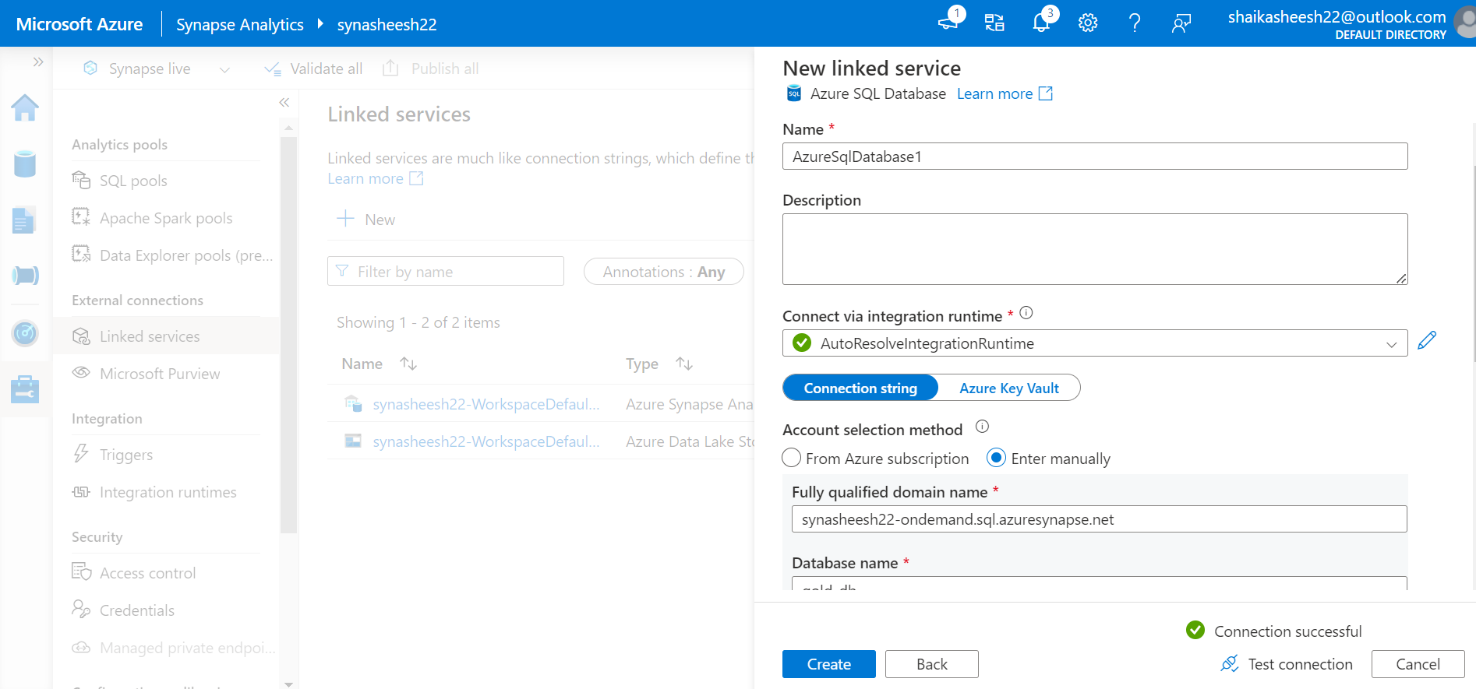

Provide the input file path for the data set

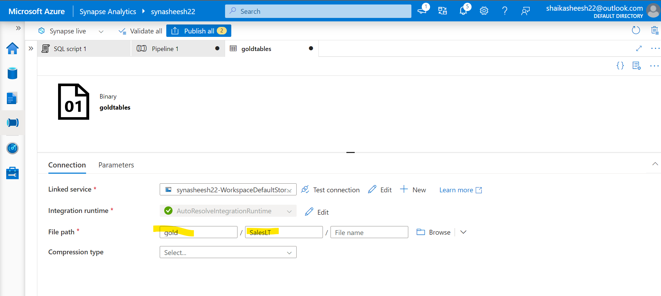

Using get metadata activity get the table names from gold folder and add an argument child items to get the Table name

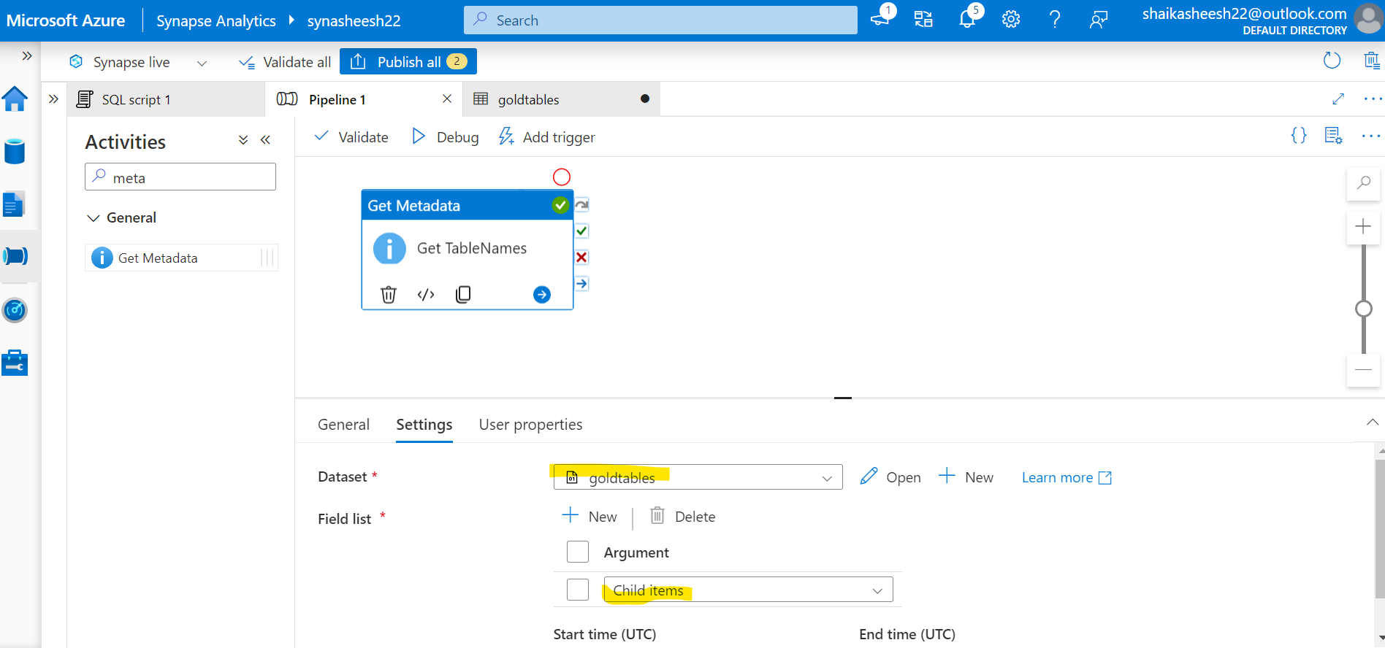

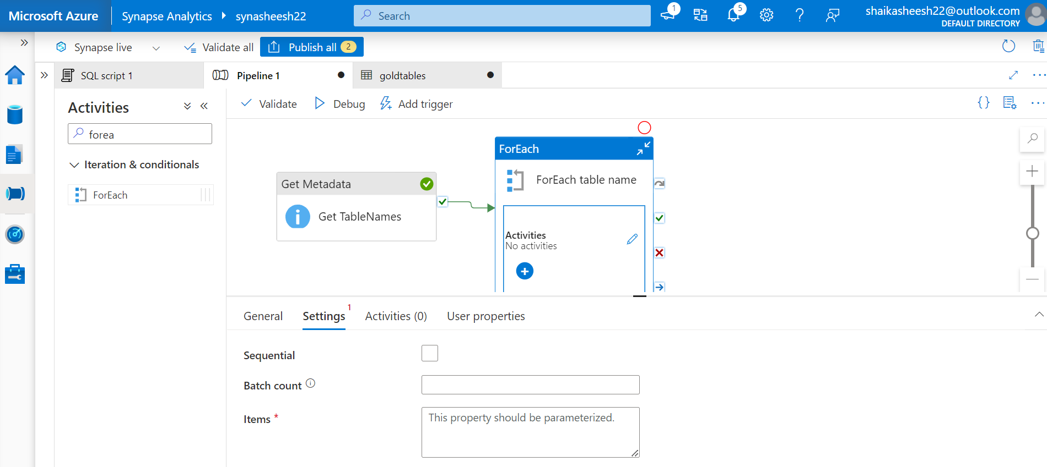

Foreach activity is used to get the input table names from get meta data activity with below shown expression

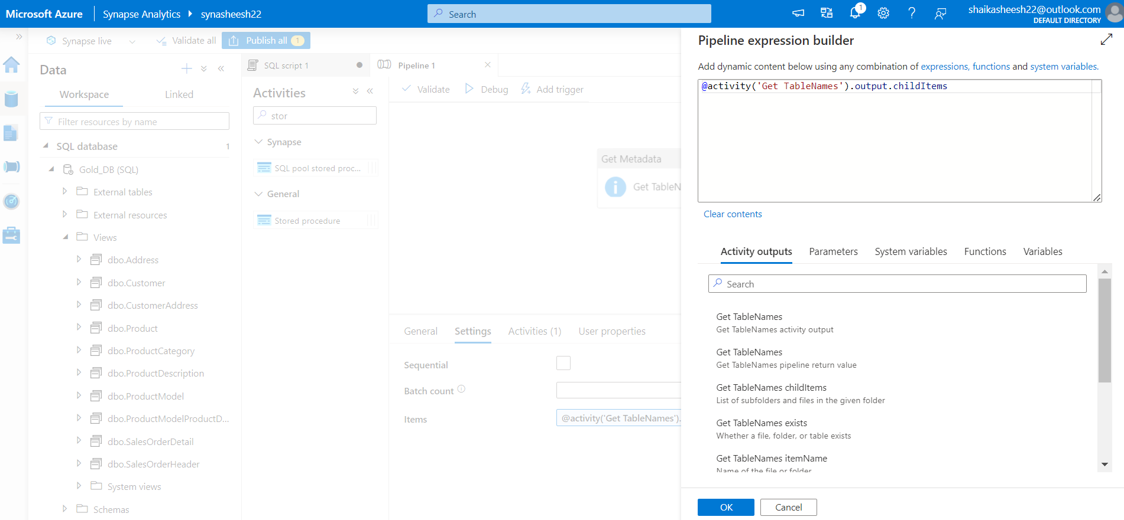

Inside for each table activity add stored procedure and give the linked service & stored procedure we have created using above SQL script. Add the parameters used in SQL script to dynamically change the values

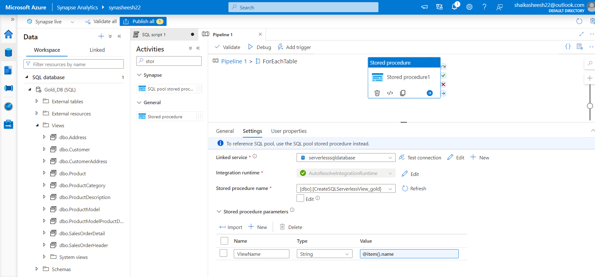

Pipeline succeeded and views are added.

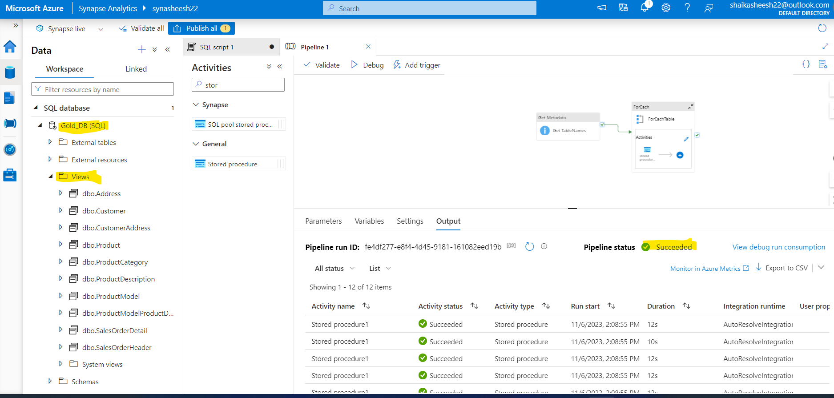

Data views are successfully loaded into syanptics space.

# Reporting section

Utilizing power BI to get data from Azure Synapse Analytics SQL and load it into Power BI and build some reports to visualize

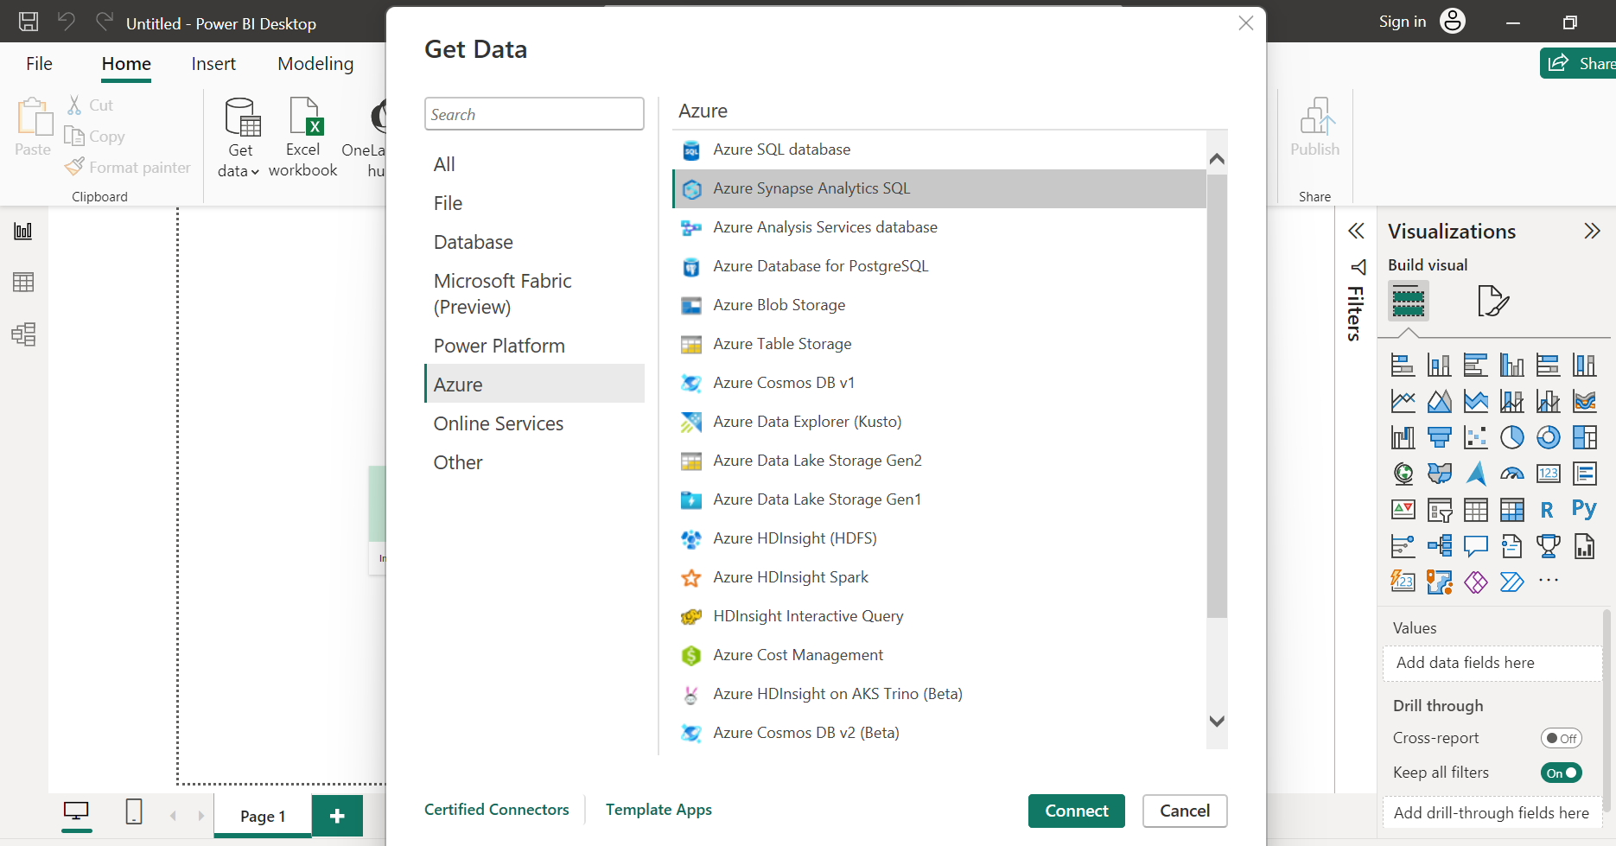

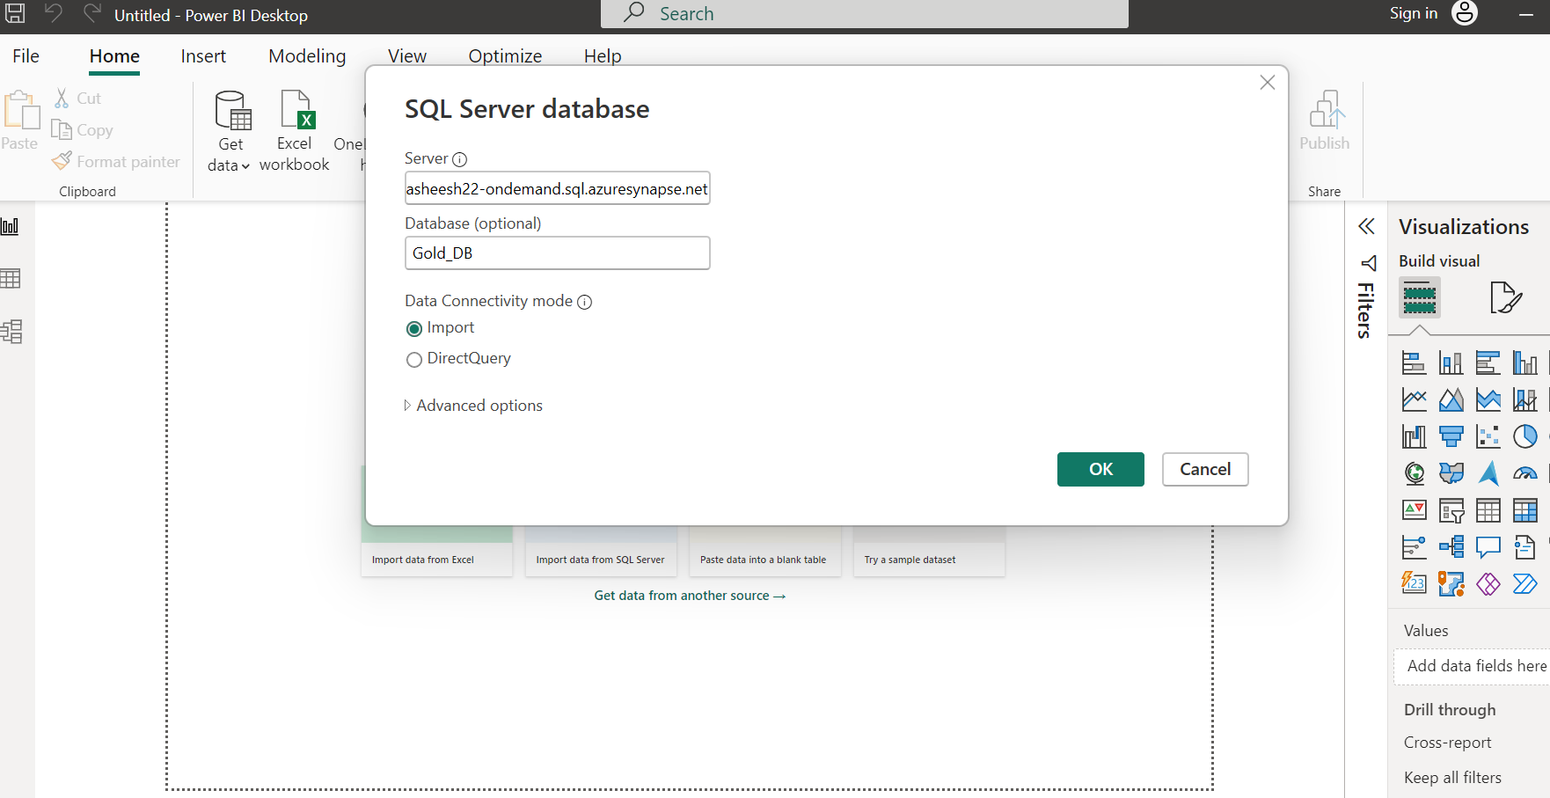

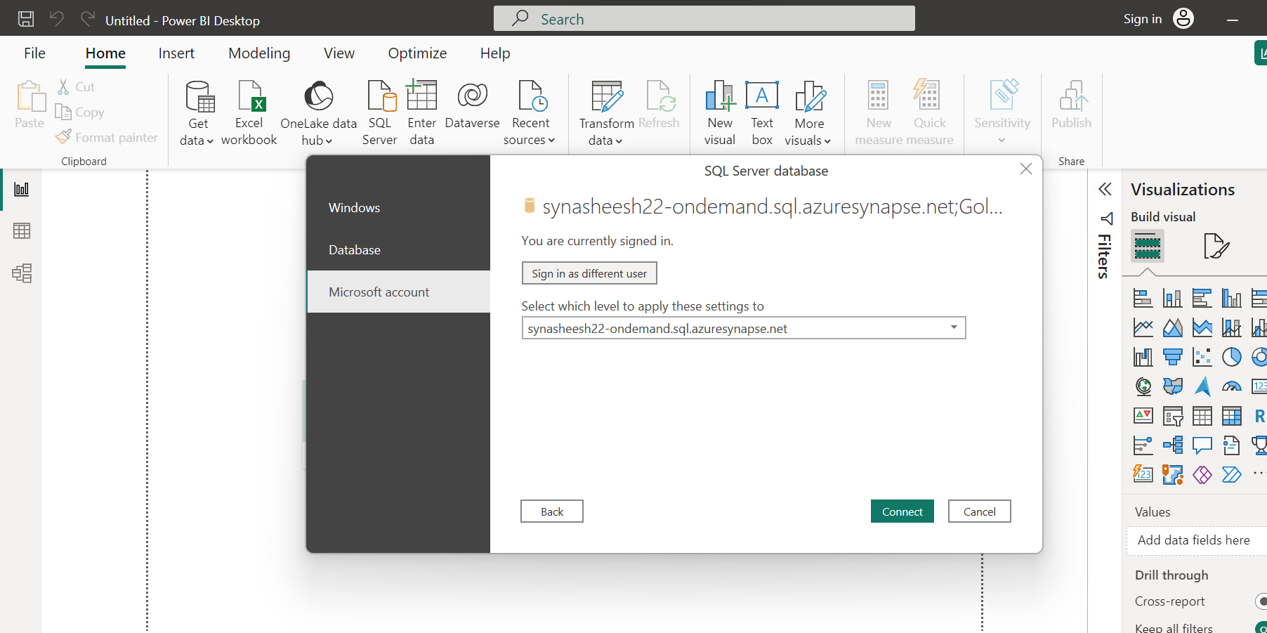

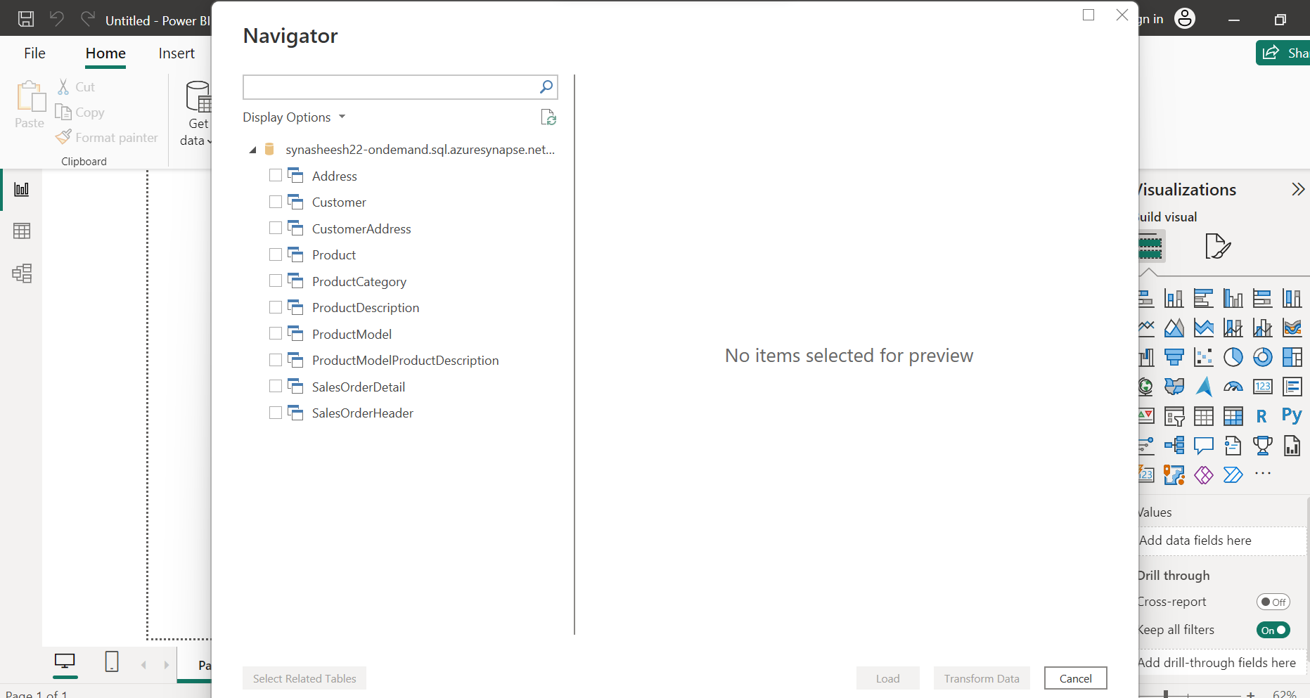

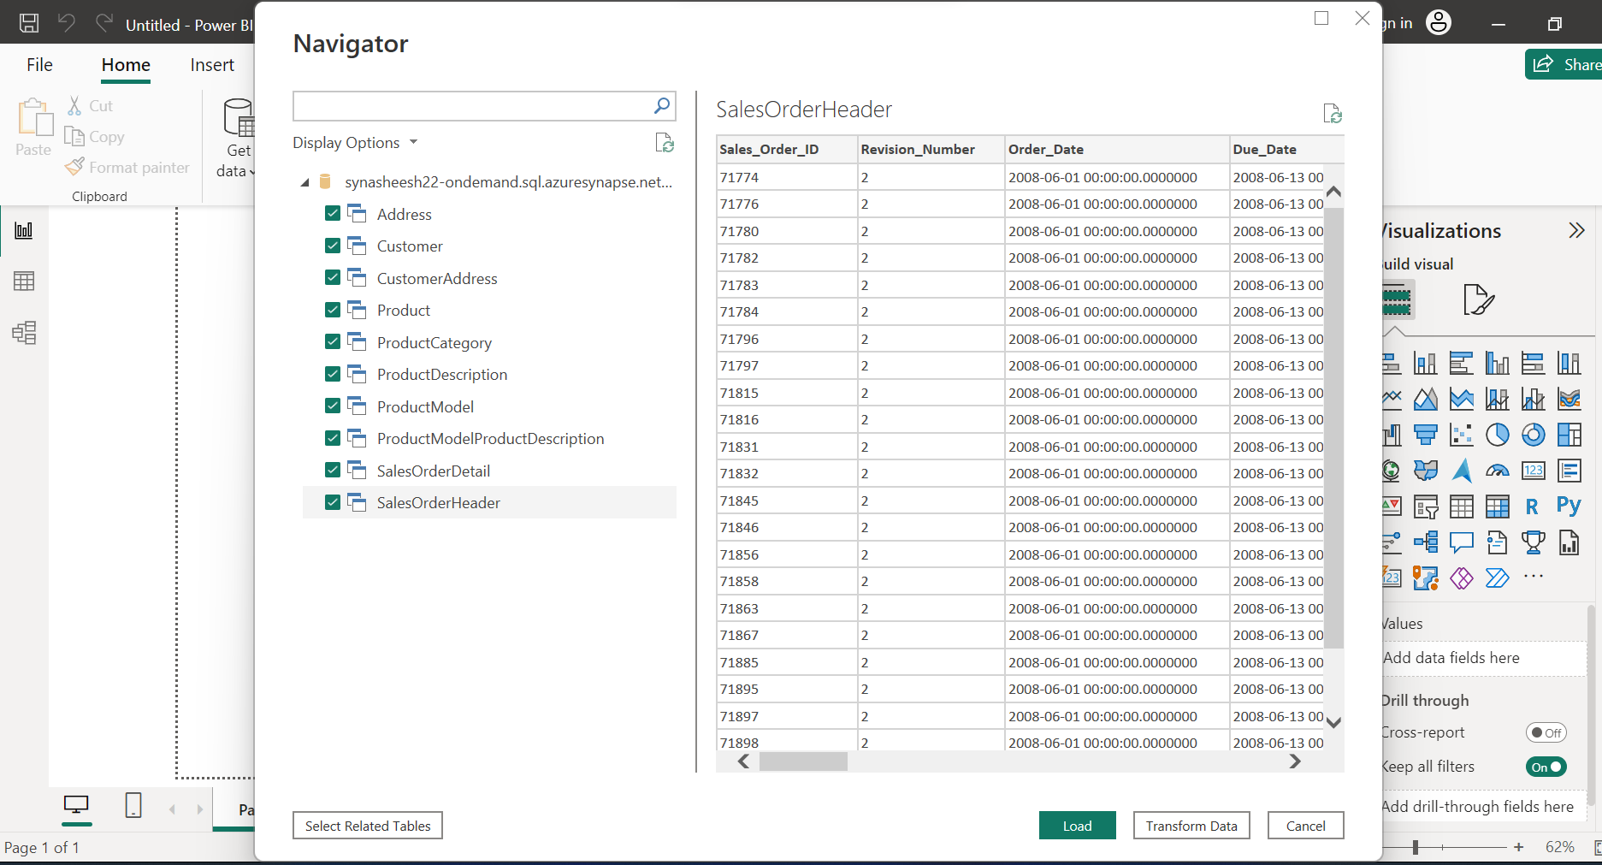

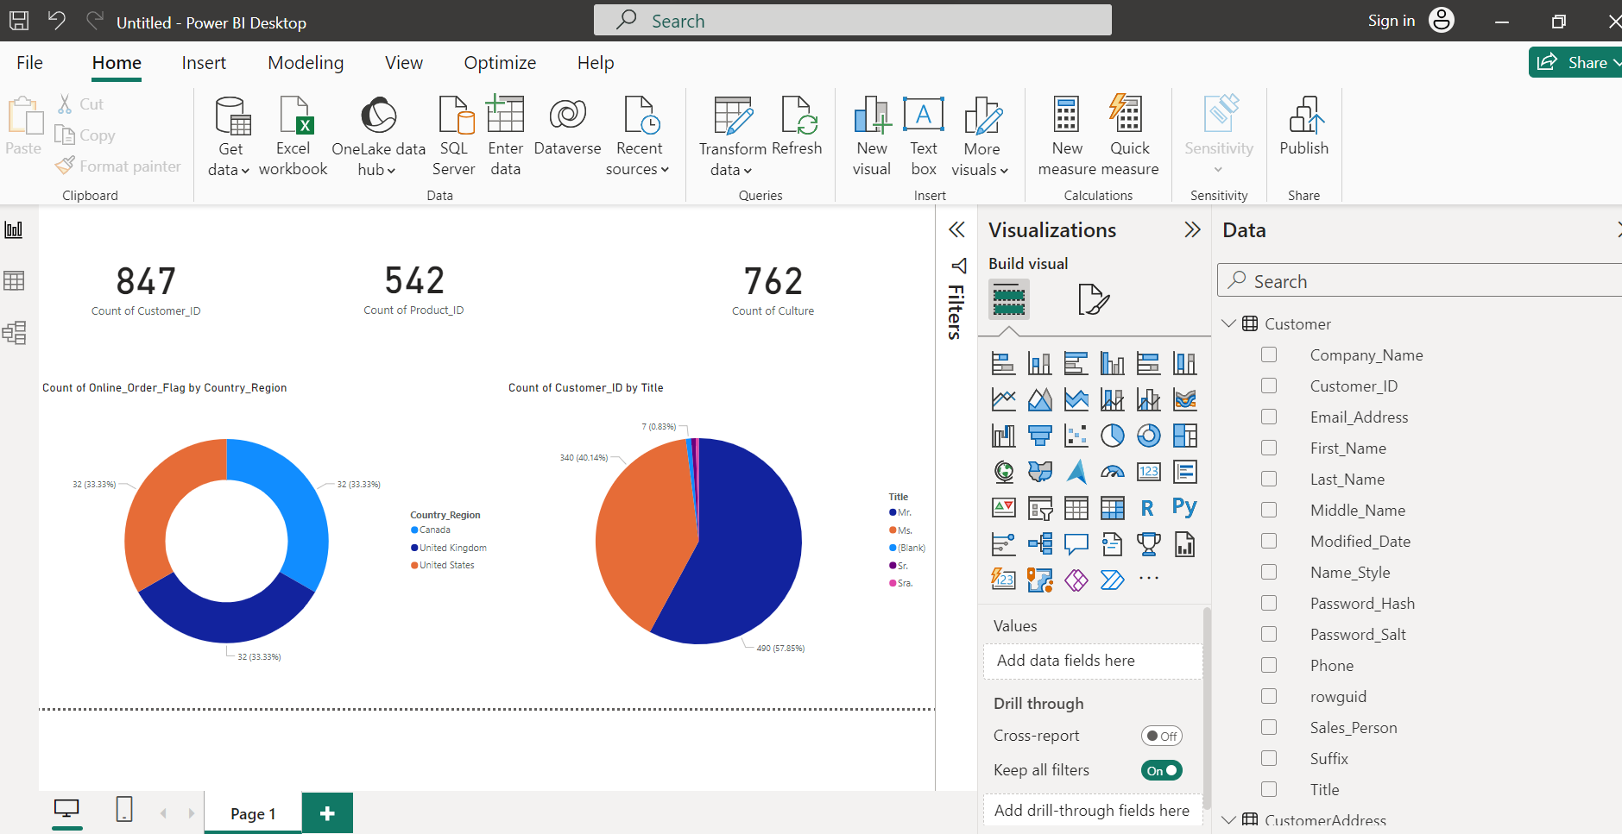

Sample Report Created

# E2E pipeline testing:

Try to add new row and check the pipeline

Updated new records in Sales LT customer table

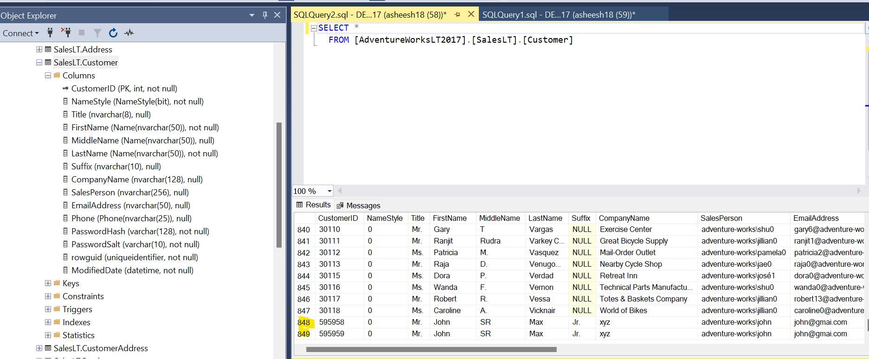

Run the pipelines and check the report

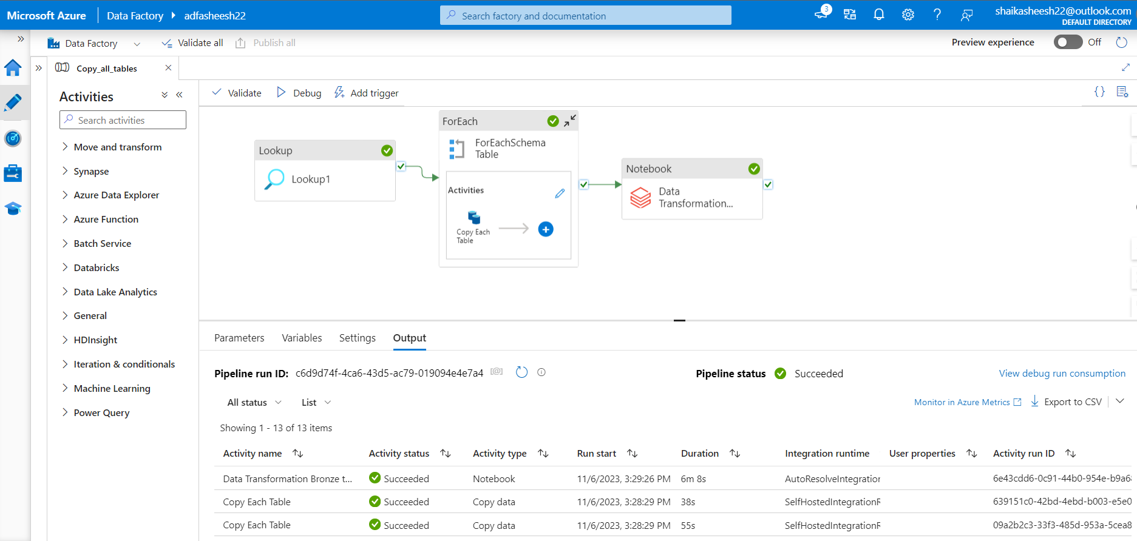

Report is updated

